

MINI PROJECT

**E-Commerce Management System**

A report submitted to the

Department of Electrical and Information Engineering

Faculty of Engineering

University of Ruhuna

Sri Lanka

On 13th of September 2025

In completing an assignment for the module

EE4203/EC4203 Database Systems

By Group No: 00

EG/2022/4905: AASIF A.K.M.

EG/2022/5226: NUSAIR M.N.M.

EG/2022/5261: RAJAAEI M.N.I.

EG/2022/5343: SHAROZ R.A.W.

EG/2022/5367: THARUKSHAN G.

TABLE OF CONTENTS

**PART A – RELATIONAL DATABASES**

CHAPTER 1 - REQUIREMENT ANALYSIS 4

* 1. Introduction 4
  2. Functional Requirements 4
  3. Data Requirements 5

CHAPTER 2 - CONCEPTUAL DESIGN (ER DIAGRAM) 8

* 1. ER Diagram 8
  2. Relations in the ER Diagram 9

2.2.1 Strong Entities

2.2.2 Weak Entities

2.2.3 Special Constructs (Recursive, Multivalued, Composite, Derived)

2.2.4 Relationship Cardinalities (min, max) notation)

CHAPTER 3 – LOGICAL DESIGN AND NORMALIZATION 11

3.1 Mapping to the Relational Model (1NF)

3.2 Functional Dependencies

3.3 Normalization to Second Normal Form (2NF)

CHAPTER 4 – IMPLEMENTATION 12

* 1. Schema Creation 12
  2. Table Creation and Definition 24
  3. Data Insertion (INSERT operations) 31
  4. Data Modification (UPDATE Operations)
  5. Data Deletion (DELETE Operations)

CHAPTER 5-TRANSACTIONS 37

5.1 Simple Queries

5.1.1 Select Operation

5.1.2 Project Operation

5.1.3 Cartesian Product

5.1.4 Create View

5.1.5 Rename Operation

5.1.6 Aggregate Function

5.1.7 LIKE Keyword

5.2 Complex Queries

5.2.1 Set Operations (Union, Intersection, Set Difference, Division)

5.2.2 Join Operations (Inner, Natural, Left Outer, Right Outer, Full Outer)

5.2.3 Nested Queries

CHAPTER 6 – DATABASE TUNING 58

6.1 Query Tuning Methodology

6.2 Analysis of Original Queries (EXPLAIN Plan)

6.3 Tuned Queries and Index Implementation

6.4 Performance Comparison (EXPLAIN Plan Analysis)

**PART B – NOSQL DATABASES**

CHAPTER 1: AGGREGATE MODEL (KEY-VALUE STORE)

1.1 Bucket Creation and Data Insertion

1.2 Query Operations on the Aggregate

CHAPTER 2: GRAPH DATA MODEL

2.1 Graph Database Creation

2.2 Querying the Social Network

**REFERENCES**

APPENDIX A: COMPLETE SQL SCRIPT

APPENDIX B: SCREENSHOTS OF NOSQL OPERATIONS

LIST OF FIGURES

Figure 1 : ER Diagram for E-Commerce Management System 9

Figure 2 Creating Database 18

# CHAPTER 1 - REQUIREMENT ANALYSIS

## Introduction

A Database Management System, or DBMS, is a fundamental computer software program for designing, managing, and accessing databases efficiently. A DBMS provides a structured interface to define a database schema, insert and update data, and extract key information useful in making business decisions. E-commerce websites are the finest examples of systems that are completely reliant on high-performance DBMS in today's digital world to handle enormous inventories, customer details, and massive volumes of transactions. It would be unpractical and error-prone to manage this complexity without a DBMS.

This project entails the design and implementation of a database for an E-Commerce Management System. This system will serve as the backbone for an online store, maintaining data about products, customers, orders, and payments. It will enable secure registration of users, efficient product cataloguing, seamless order processing, and guaranteed payment tracking. Therefore, this database is an essential resource for business owners, administrators, and customers to access a single source of truth regarding all e-commerce activity and to make retrieving data-driven insights effortless.

## Functional Requirements

The E-Commerce Management System shall incorporate the following characteristics

* The system shall facilitate new customers to sign up and create a personal account.
* The system shall facilitate registered customers to log in securely to their accounts.
* The system shall facilitate customers to view, edit, and maintain their personal profile and shipping addresses.
* The system shall facilitate administrators to add, edit, and remove product listings from the catalogue.
* The system will allow customers to browse products by product categories and search for products by product name or product description.
* The system will allow customers to place products into an online shopping cart, update item quantities, and remove items.
* The system will allow customers to check out and have the shopping cart contents transferred into an official order.
* The system will debit payments against orders and change the status of the order after successful payment.
* The system will manage product stock, decreasing automatically when a successful order is completed.
* The system will allow customers to view their ordering history and the status of all orders.
* The system will allow user views to generate user-specific reports of sales levels and popularity of products.

## Data Requirements

The system must store and manage the following core data entities and their attributes to support the functional requirements

Entity: Customer - Attributes

* Customer ID
* Email
* Password Hash
* First Name
* Last Name
* Phone
* Registration Date

Entity: Address - Attributes

* Address ID
* Customer ID
* Address Line 1
* Address Line 2
* City
* State
* Zip Code
* Address Type

Entity: Category - Attributes

* Category ID
* Category Name
* Description
* Parent Category ID

Entity: Product - Attributes

* Product ID
* Product Name
* Description
* Price
* Stock Quantity
* Weight
* Date Added
* Status
* Category ID

Entity: ProductImage - Attributes

* Product ID
* Image URL

Entity: ShoppingCart - Attributes

* Cart ID
* Creation Date
* Customer ID

Entity: CartItem - Attributes

* Cart ID
* Product ID
* Quantity

Entity: Order - Attributes

* Order ID
* Order Date
* Total Amount
* Status
* Customer ID

Entity: OrderItem - Attributes

* Order ID
* Product ID
* Quantity
* Unit Price

Entity: Payment - Attributes

* Payment ID
* Payment Method
* Amount
* Transaction Date
* Status
* Order ID

# CHAPTER 2 - CONCEPTUAL DESIGN (ER DIAGRAM)

## 2.1 ER Diagram

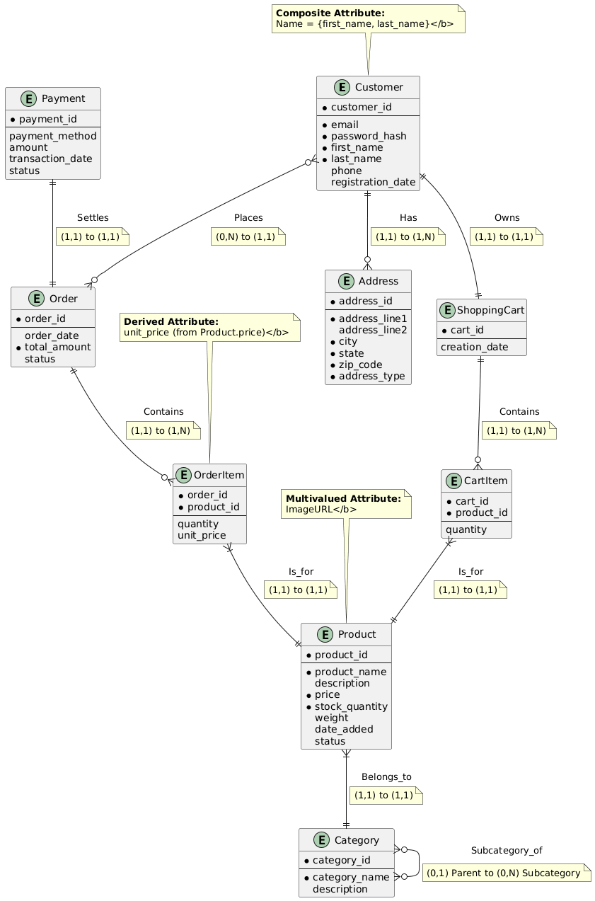

Figure 1 : ER Diagram for E-Commerce Management System

## 2.2 Relations in the ER Diagram

The Entity-Relationship (ER) diagram created provides a complete conceptual view of the database for the E-Commerce Management System. The key elements and design decisions included in the diagram are explained in this section.

### 2.2.1 Strong Entities

Strong entities are those that exist independently and do not rely on any other entity for their identification. Their primary key is uniquely defined by their own attributes.

* Customer: Represents a registered user of the platform.
* Category: Represents a classification for products (e.g., Electronics, Clothing).
* Product: Represents an item available for sale.
* ShoppingCart: Represents a virtual cart associated with a single customer.
* Order: Represents a completed purchase transaction.
* Payment: Represents a financial transaction that settles an order.

2.2.2 Weak Entities

Weak entities are existence-dependent on a strong entity. Their primary key is partially or fully derived from the primary key of the strong entity they relate to.

* Address: A weak entity that depends on the Customer entity. An address cannot exist without a customer.
* CartItem: A weak entity that depends on the ShoppingCart entity. An item cannot be in a cart without the cart itself.
* ProductImage: A weak entity that depends on the Product entity. An image cannot exist without a product.

2.2.3 Relationship Cardinalities

One-to-One (1 : 1) Relationships

* Customer OWNS ShoppingCart: (1, 1) to (1, 1)  
  One Customer must own exactly one ShoppingCart. One ShoppingCart is owned by exactly one Customer.
* Payment SETTLES Order: (1, 1) to (1, 1)  
  One Payment must settle exactly one Order. One Order must be settled by exactly one Payment.

One-to-Many (1 : N) Relationships

* Customer PLACES Order: (0, N) to (1, 1)  
  One Customer can place zero or many Orders. One Order must be placed by exactly one Customer.
* Customer HAS Address: (1, 1) to (1, N)  
  One Customer must have one or more Addresses. One Address must belong to exactly one Customer.
* ShoppingCart CONTAINS CartItem: (1, 1) to (1, N)  
  One ShoppingCart must contain one or more CartItems. One CartItem must be contained in exactly one ShoppingCart.
* Order CONTAINS OrderItem: (1, 1) to (1, N)  
  One Order must contain one or more OrderItems. One OrderItem must be part of exactly one Order.
* Product BELONGS_TO Category: (1, 1) to (1, 1)  
  One Product must belong to exactly one Category. One Category can have one or many Products.
* Product HAS ProductImage: (1, 1) to (1, N)  
  One Product must have one or more ProductImages. One ProductImage must belong to exactly one Product.

Many-to-Many (M : N) Relationships

* The relationship between Product and ShoppingCart is resolved by the weak entity CartItem. One ShoppingCart can contain many Products, and one Product can be in many ShoppingCarts.
* The relationship between Product and Order is resolved by the weak entity OrderItem. One Order can contain many Products, and one Product can be in many Orders.

Recursive Relationship

* Category IS_SUBCATEGORY_OF Category: (0, 1) to (0, N)  
  This is a one-to-many relationship within the same entity. One Category (as a parent) can have zero or many subcategories. One Category (as a subcategory) can have zero or one parent Categories.

2.2.4 Special Constructs

Composite Attributes

* Customer Name: Composed of the atomic attributes First Name and Last Name.
* Customer Address: (In the Address entity) Composed of Address Line 1, Address Line 2, City, State, and Zip Code.

Multivalued Attributes

* Product Image: A product can have multiple image URLs. This is modeled as the separate weak entity ProductImage.

Derived Attribute

* OrderItem.UnitPrice: This attribute is derived from the Price attribute in the Product entity at the time the order is placed. It is stored historically in the OrderItem entity to preserve the sale price, making it a derived and stored attribute.

# CHAPTER 3 – LOGICAL DESIGN AND NORMALIZATION

3.1 Mapping to the Relational Model (1NF)

The following tables represent the initial mapping of the ER diagram to a relational schema in First Normal Form (1NF). Each table has a primary key, and all attributes are atomic.

1. Customer Table

| Attribute | Data Type | Constraints |
| --- | --- | --- |
| customer_id | INT | PRIMARY KEY |
| email | VARCHAR(255) | NOT NULL, UNIQUE |
| password_hash | VARCHAR(255) | NOT NULL |
| first_name | VARCHAR(100) | NOT NULL |
| last_name | VARCHAR(100) | NOT NULL |
| phone | VARCHAR(20) |  |
| registration_date | DATE | NOT NULL |

2. Address Table

| Attribute | Data Type | Constraints |
| --- | --- | --- |
| address_id | INT | PRIMARY KEY |
| customer_id | INT | NOT NULL, FOREIGN KEY |
| address_line1 | VARCHAR(255) | NOT NULL |
| address_line2 | VARCHAR(255) |  |
| city | VARCHAR(100) | NOT NULL |
| state | VARCHAR(100) | NOT NULL |
| zip_code | VARCHAR(20) | NOT NULL |
| address_type | ENUM('S','B') | NOT NULL |

3. Category Table

| Attribute | Data Type | Constraints |
| --- | --- | --- |
| category_id | INT | PRIMARY KEY |
| category_name | VARCHAR(100) | NOT NULL |
| description | TEXT |  |
| parent_category_id | INT | FOREIGN KEY (self) |

4. Product Table

| Attribute | Data Type | Constraints |
| --- | --- | --- |
| product_id | INT | PRIMARY KEY |
| product_name | VARCHAR(255) | NOT NULL |
| description | TEXT |  |
| price | DECIMAL(10,2) | NOT NULL |
| stock_quantity | INT | NOT NULL |
| weight | DECIMAL(10,2) |  |
| date_added | DATE | NOT NULL |
| status | ENUM('A','I') | NOT NULL |
| category_id | INT | NOT NULL, FOREIGN KEY |

5. ProductImage Table

| Attribute | Data Type | Constraints |
| --- | --- | --- |
| product_id | INT | FOREIGN KEY (PK) |
| image_url | VARCHAR(500) | NOT NULL (PK) |
| PRIMARY KEY (product_id, image_url) |  |  |

6. ShoppingCart Table

| Attribute | Data Type | Constraints |
| --- | --- | --- |
| cart_id | INT | PRIMARY KEY |
| creation_date | DATE | NOT NULL |
| customer_id | INT | NOT NULL, UNIQUE, FK |

7. CartItem Table

| Attribute | Data Type | Constraints |
| --- | --- | --- |
| cart_id | INT | FOREIGN KEY (PK) |
| product_id | INT | FOREIGN KEY (PK) |
| quantity | INT | NOT NULL, CHECK > 0 |
| PRIMARY KEY (cart_id, product_id) |  |  |

8. Order Table

| Attribute | Data Type | Constraints |
| --- | --- | --- |
| order_id | INT | PRIMARY KEY |
| order_date | DATETIME | NOT NULL |
| total_amount | DECIMAL(10,2) | NOT NULL |
| status | ENUM('P','D','C') | NOT NULL |
| customer_id | INT | NOT NULL, FOREIGN KEY |

9. OrderItem Table

| Attribute | Data Type | Constraints |
| --- | --- | --- |
| order_id | INT | FOREIGN KEY (PK) |
| product_id | INT | FOREIGN KEY (PK) |
| quantity | INT | NOT NULL, CHECK > 0 |
| unit_price | DECIMAL(10,2) | NOT NULL |
| PRIMARY KEY (order_id, product_id) |  |  |

10. Payment Table

| Attribute | Data Type | Constraints |
| --- | --- | --- |
| payment_id | INT | PRIMARY KEY |
| payment_method | VARCHAR(50) | NOT NULL |
| amount | DECIMAL(10,2) | NOT NULL |
| transaction_date | DATETIME | NOT NULL |
| status | ENUM('S','F','R') | NOT NULL |
| order_id | INT | NOT NULL, UNIQUE, FK |

## 3.2 Functional Dependencies

For each table, the primary key functionally determines all other attributes.

* **Customer:** customer_id → {email, password_hash, first_name, last_name, phone, registration_date}
* **Address:** address_id → {customer_id, address_line1, address_line2, city, state, zip_code, address_type}
* **Category:** category_id → {category_name, description, parent_category_id}
* **Product:** product_id → {product_name, description, price, stock_quantity, weight, date_added, status, category_id}
* **ProductImage:** {product_id, image_url} → {} (No other attributes)
* **ShoppingCart:** cart_id → {creation_date, customer_id}
* **CartItem:** {cart_id, product_id} → quantity
* **Order:** order_id → {order_date, total_amount, status, customer_id}
* **OrderItem:** {order_id, product_id} → {quantity, unit_price}
* **Payment:** payment_id → {payment_method, amount, transaction_date, status, order_id}

## 3.3 Normalization to Second Normal Form (2NF)

All tables are already in 2NF because:

1. They are all in 1NF (atomic values, no repeating groups).
2. They have no partial dependencies. In all tables with composite primary keys (ProductImage, CartItem, OrderItem), the non-key attributes depend on the entire composite key, not just a part of it. For example, in OrderItem, the quantity and unit_price depend on both the order_id and the product_id together.

No further normalization is required to achieve 2NF. The schema is now optimized to avoid update anomalies and redundancy for this normal form.

# CHAPTER 4 – IMPLEMENTATION

## 4.1 Schema Creation

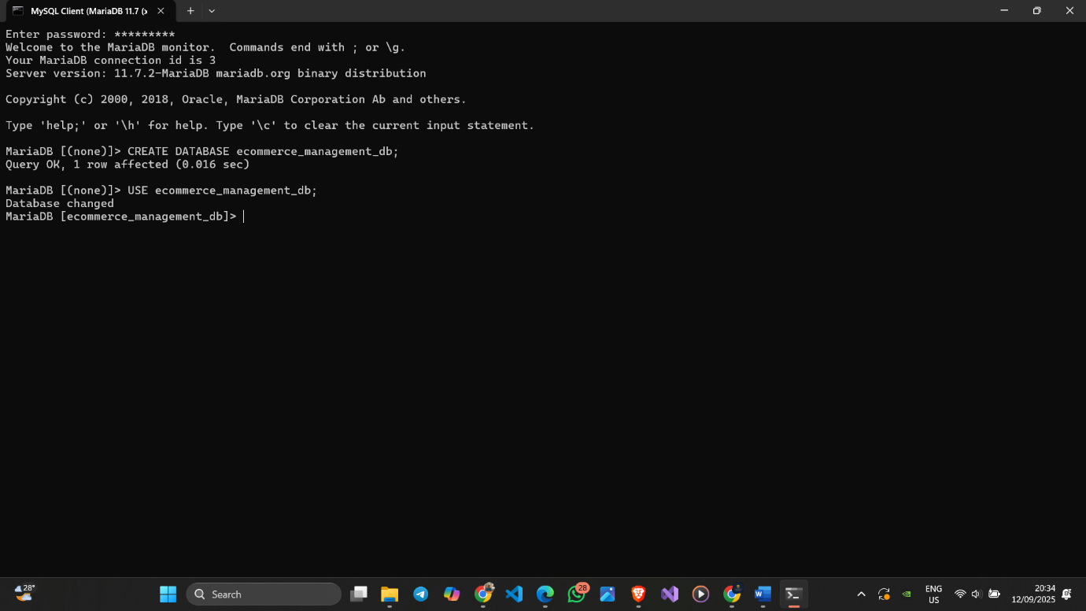

Figure 2 Creating Database

## 4.2 Table Creation and Definition

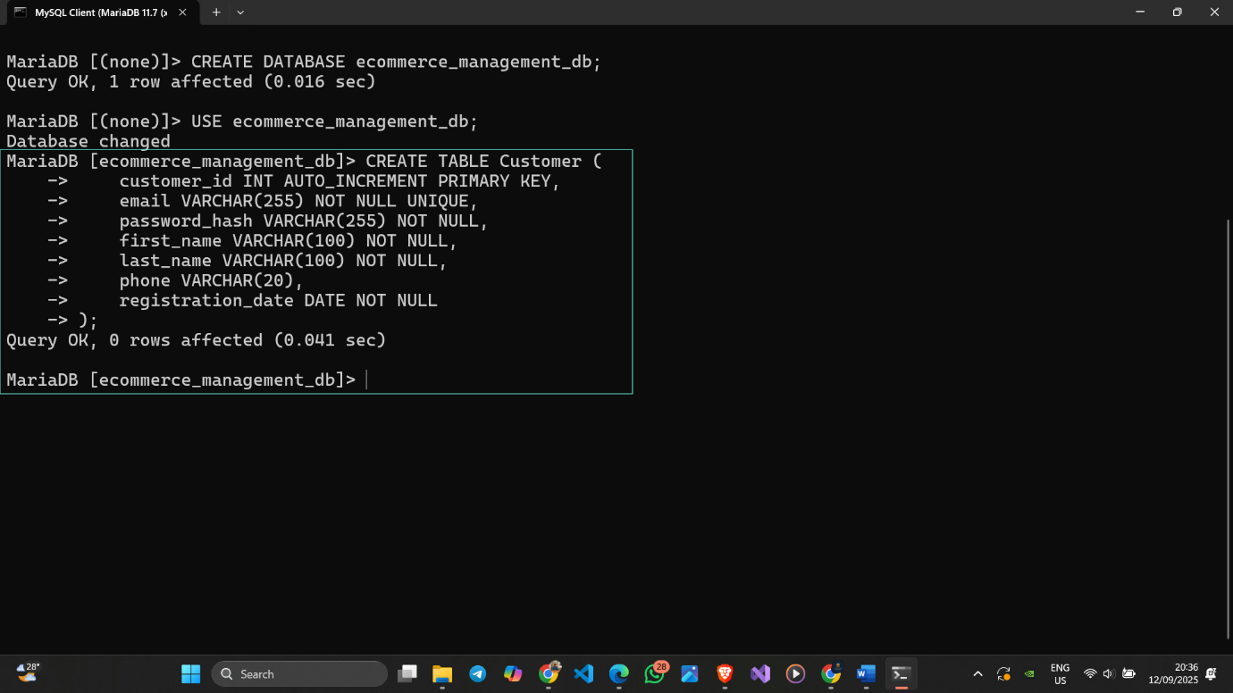

Figure 3 Creating Customer Table

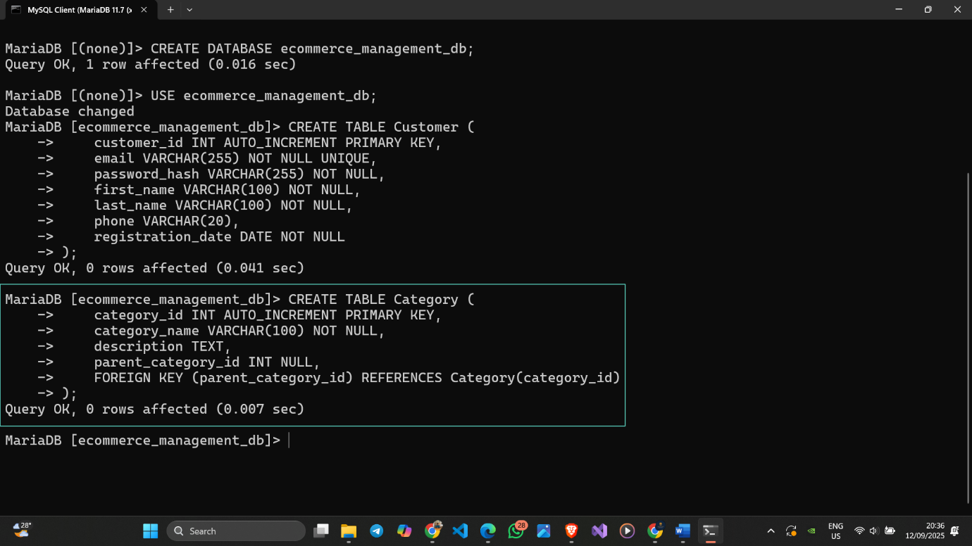

Figure 4 Creating Category Table

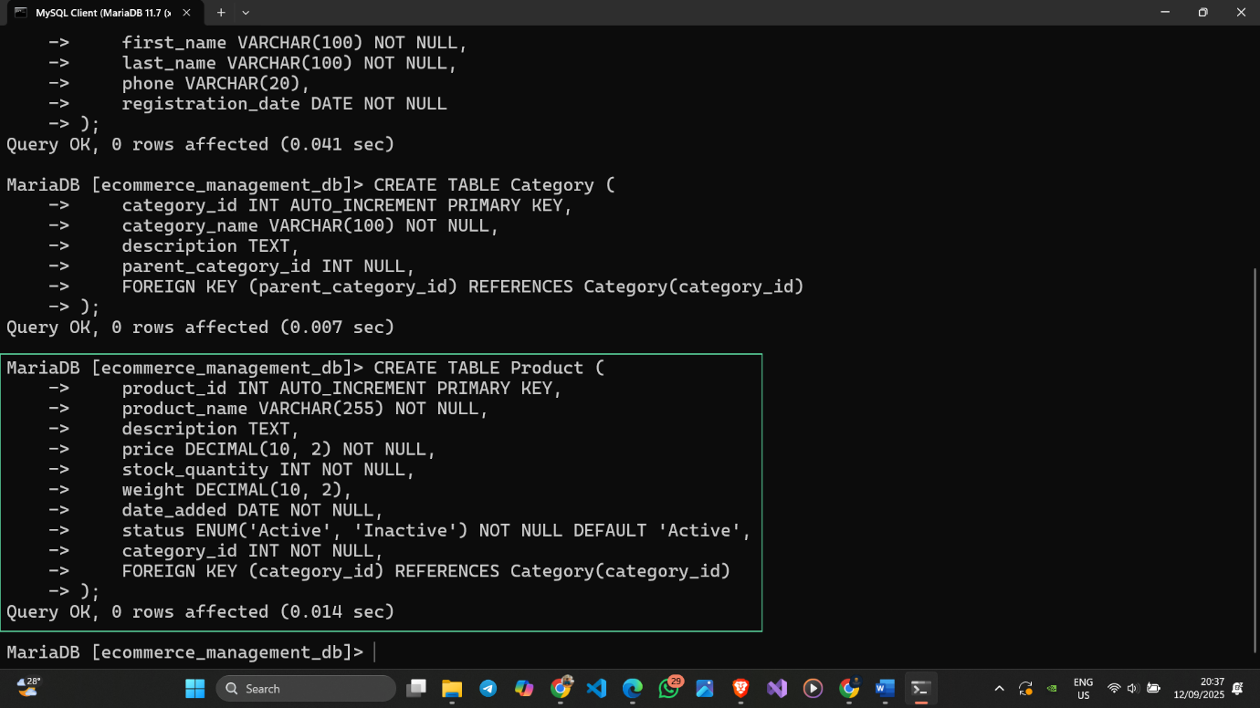

Figure 5 Creating Product Table

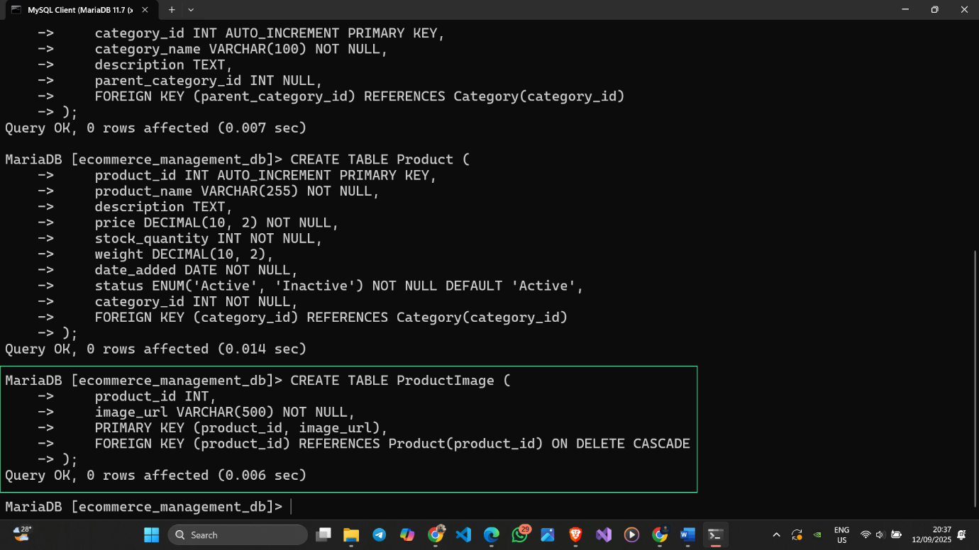

Figure 6 Creating ProductImage Table

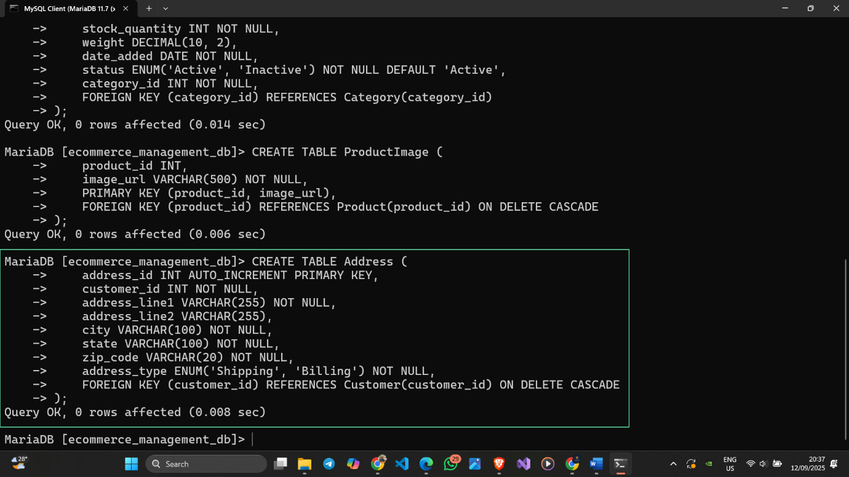

Figure 7 Creating Address Table

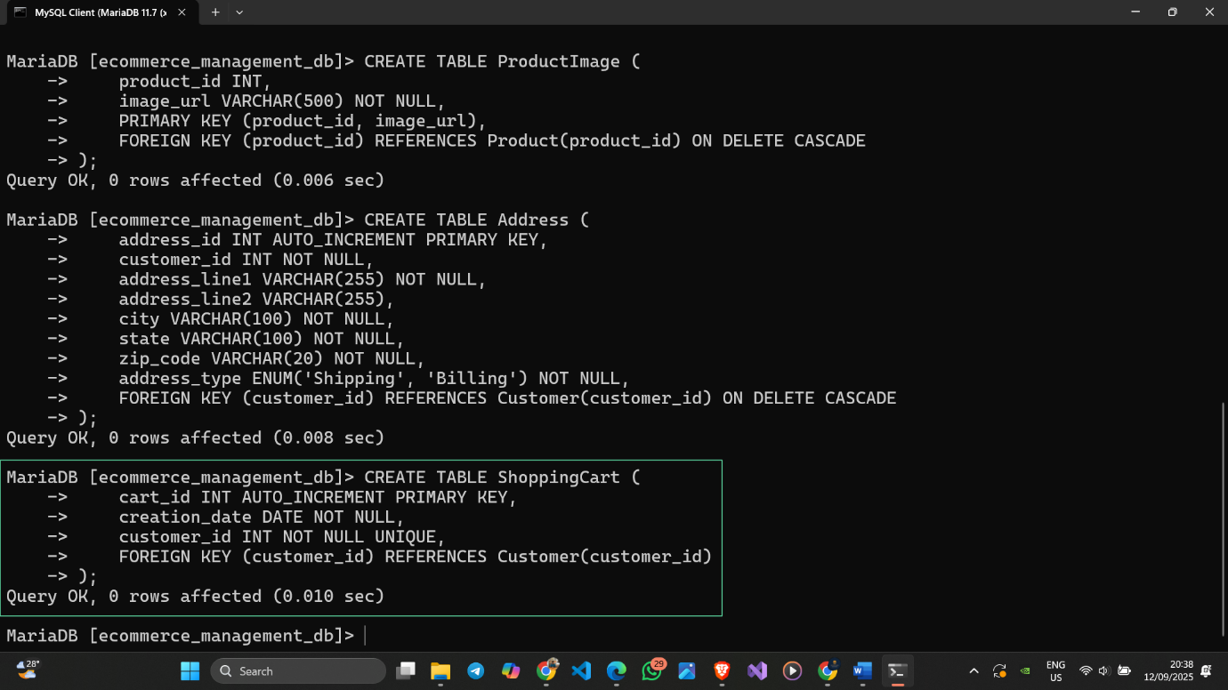

Figure 8 Creating ShoppingCart Table

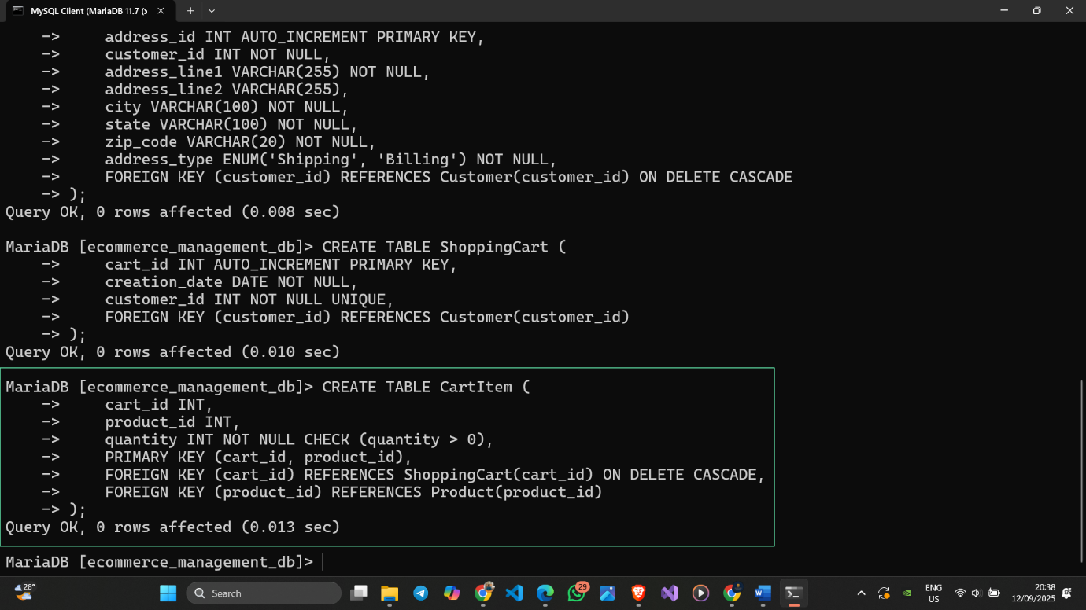

Figure 9 Creating CartItem Table

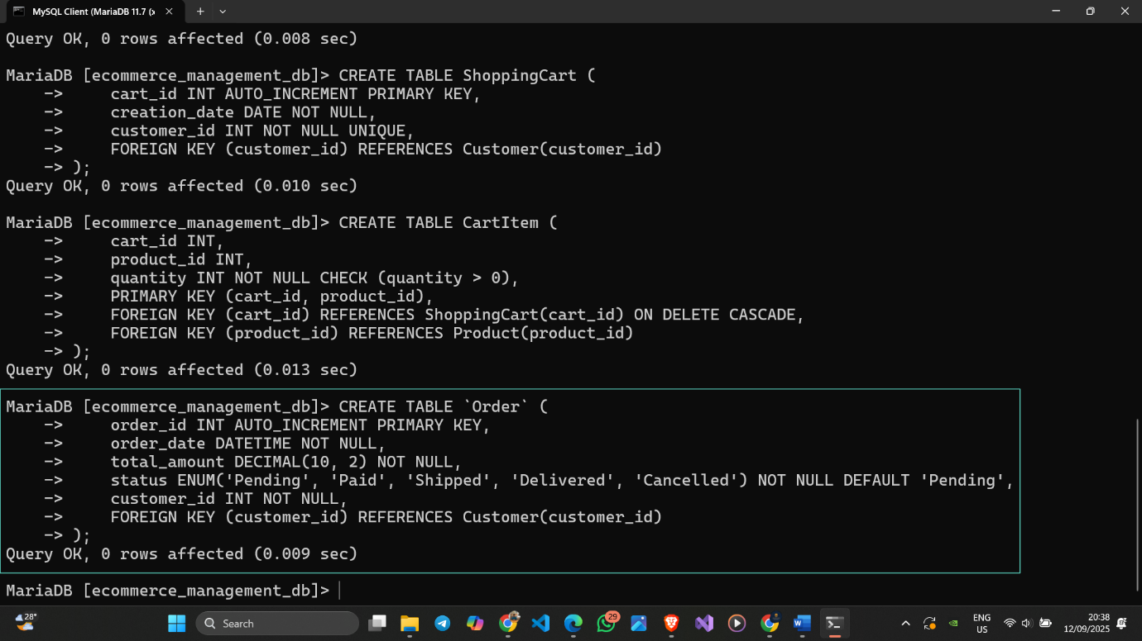

Figure 10 Creating Order Table

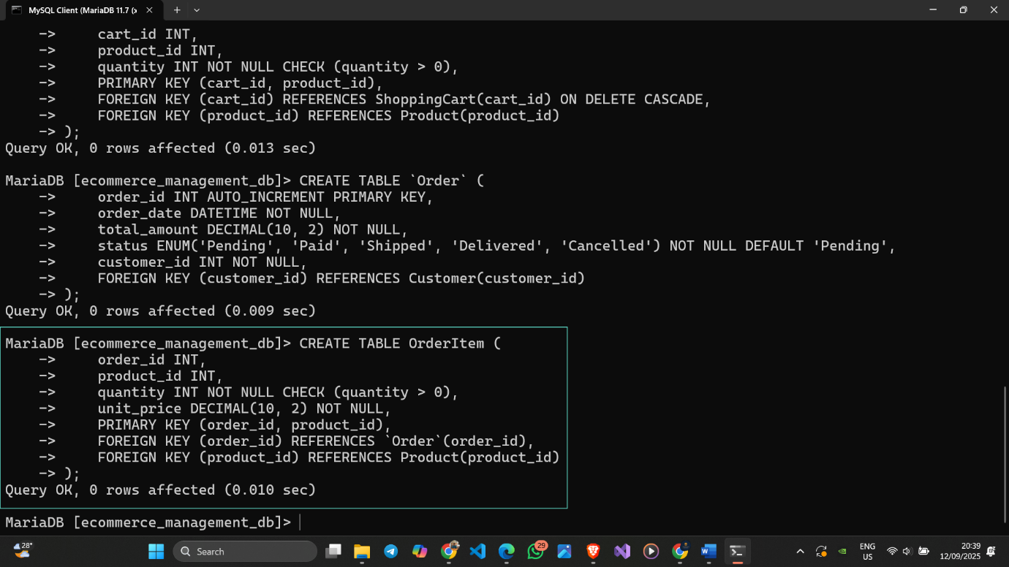

Figure 11 Creating OrderItem Table

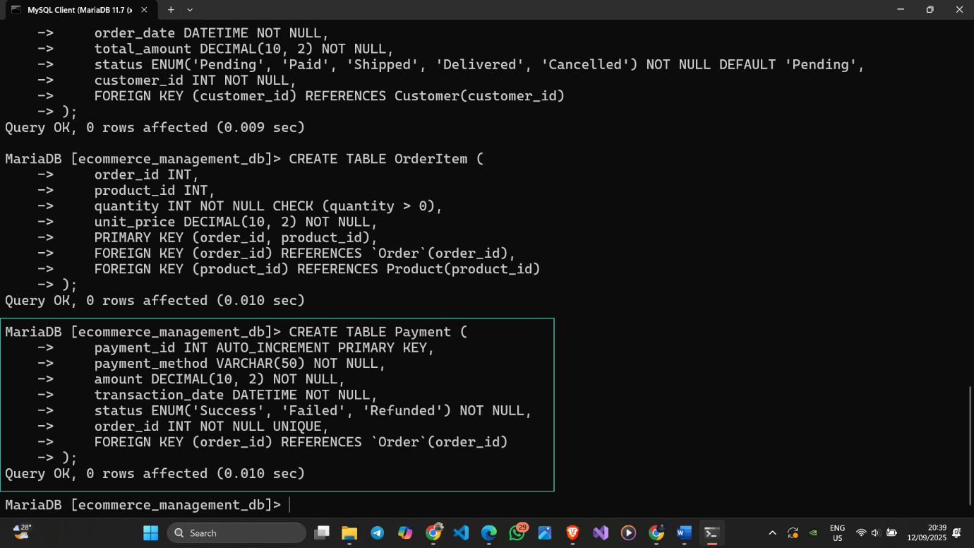

Figure 12 Creating Payment Table

## 4.3 Data Insertion (INSERT operations)

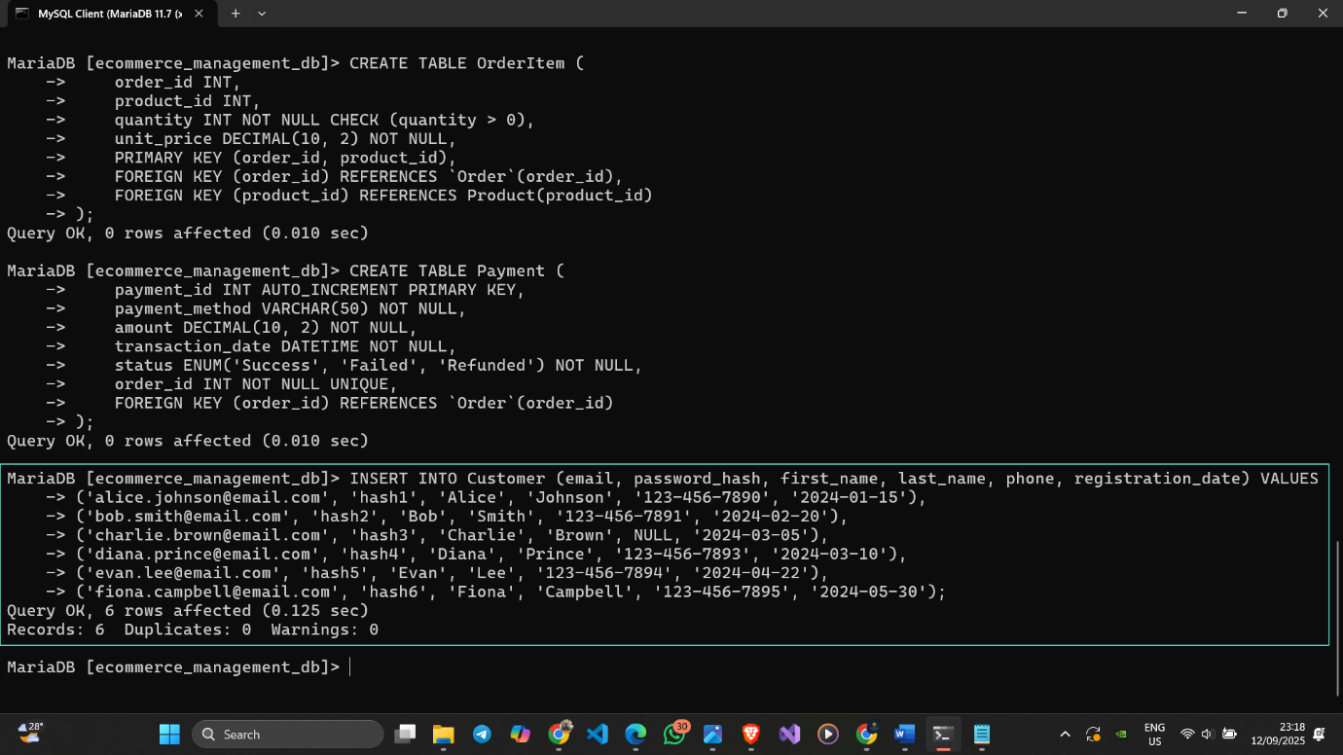

Figure 13 Inserting Data to the Customer Table

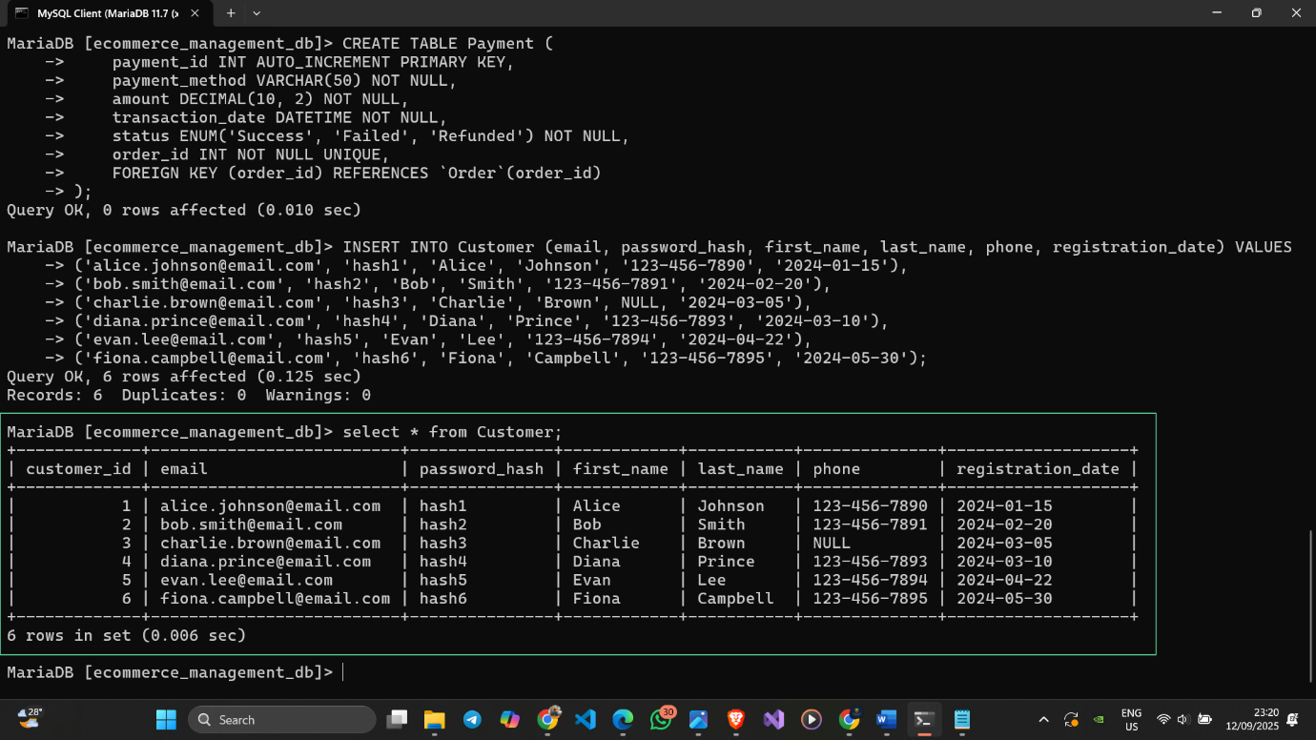

Figure 14 Customer Table with Inserted Data

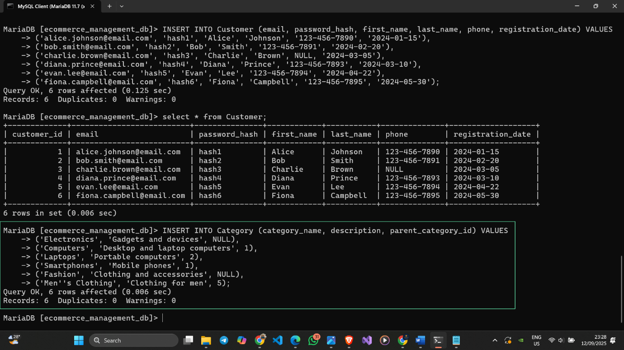

Figure 15 Inserting Data to the Category Table

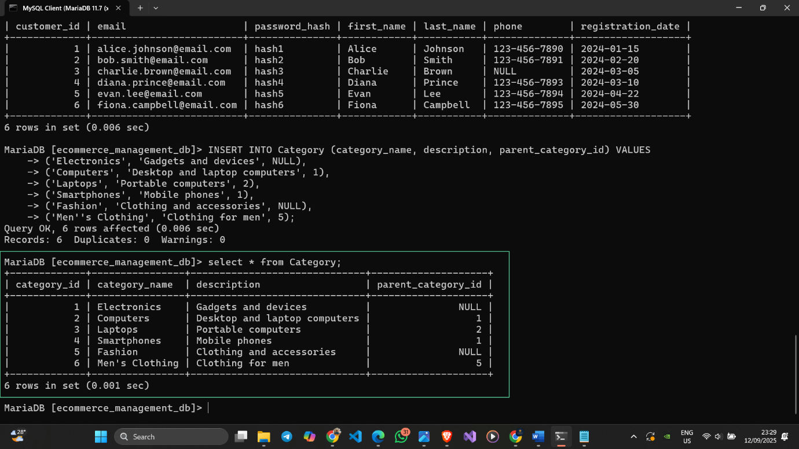

Figure 16 Category Table with Inserted Data

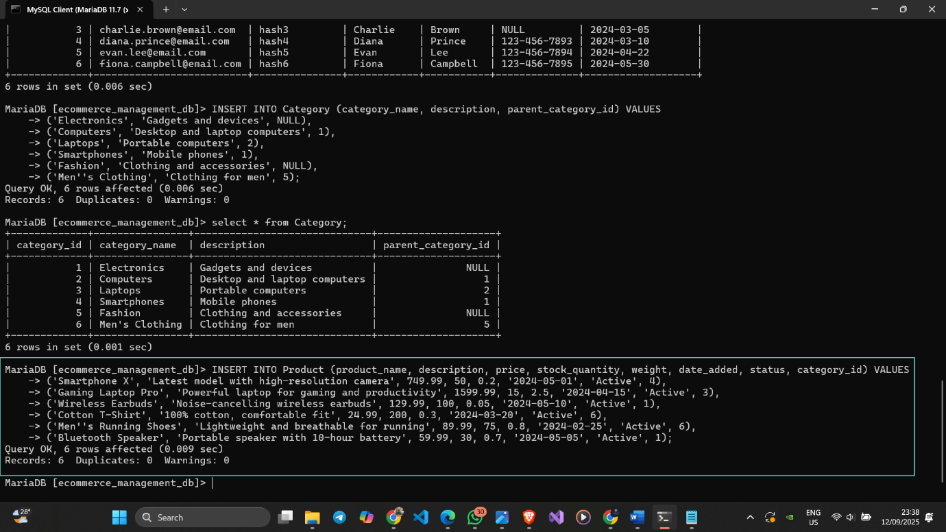

Figure 17 Inserting Data to the Product Table

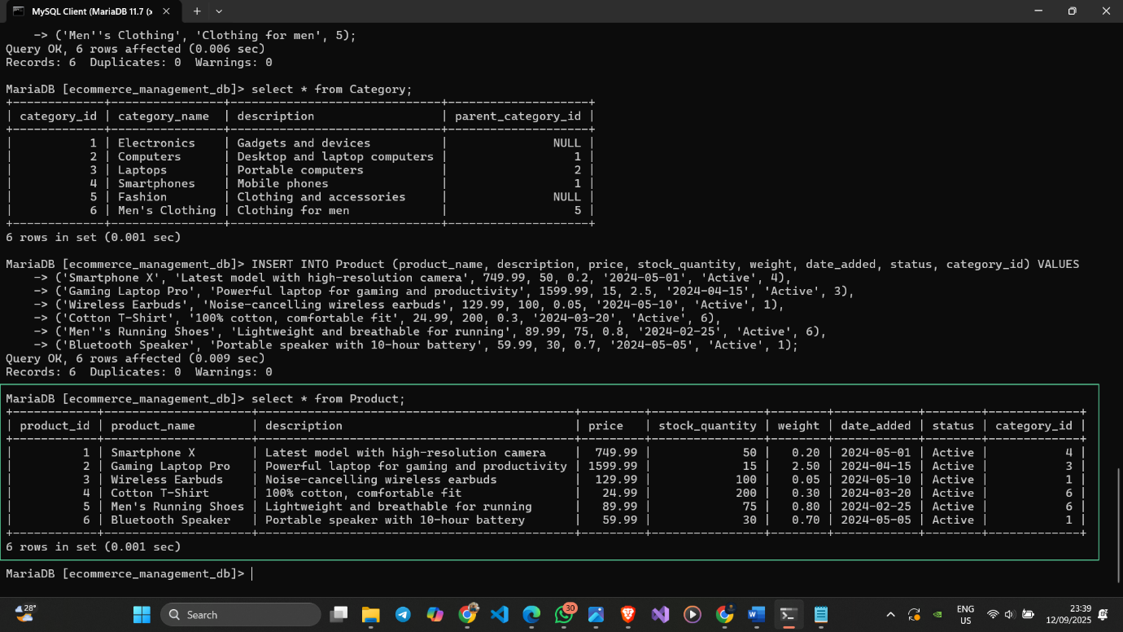

Figure 18 Product Table with Inserted Data

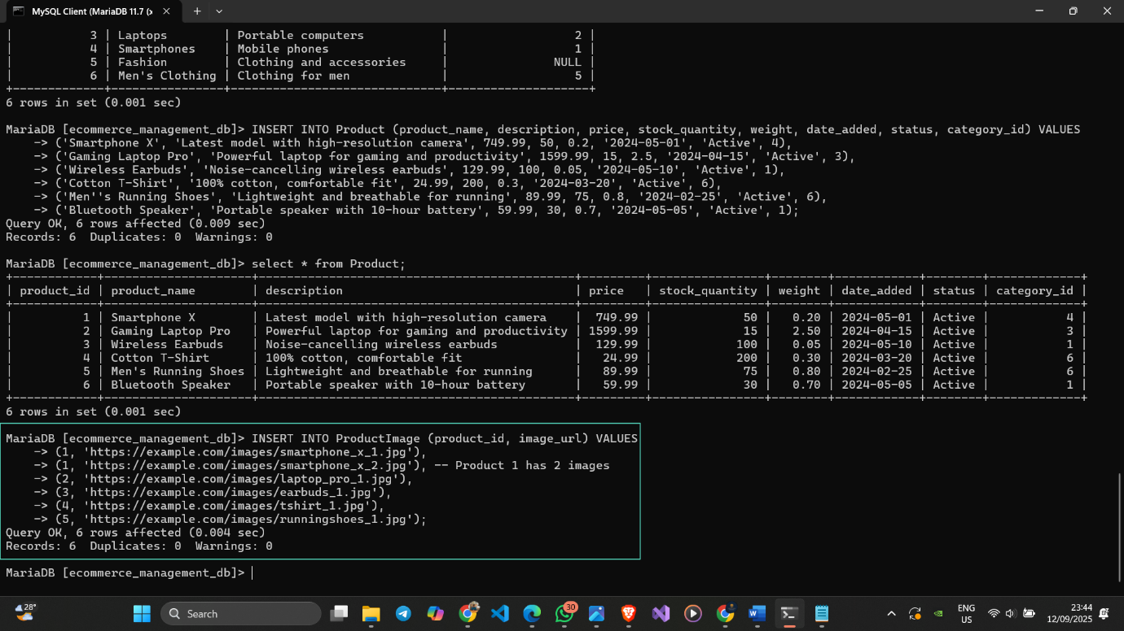

Figure 19 Inserting Data to the ProductImage Table

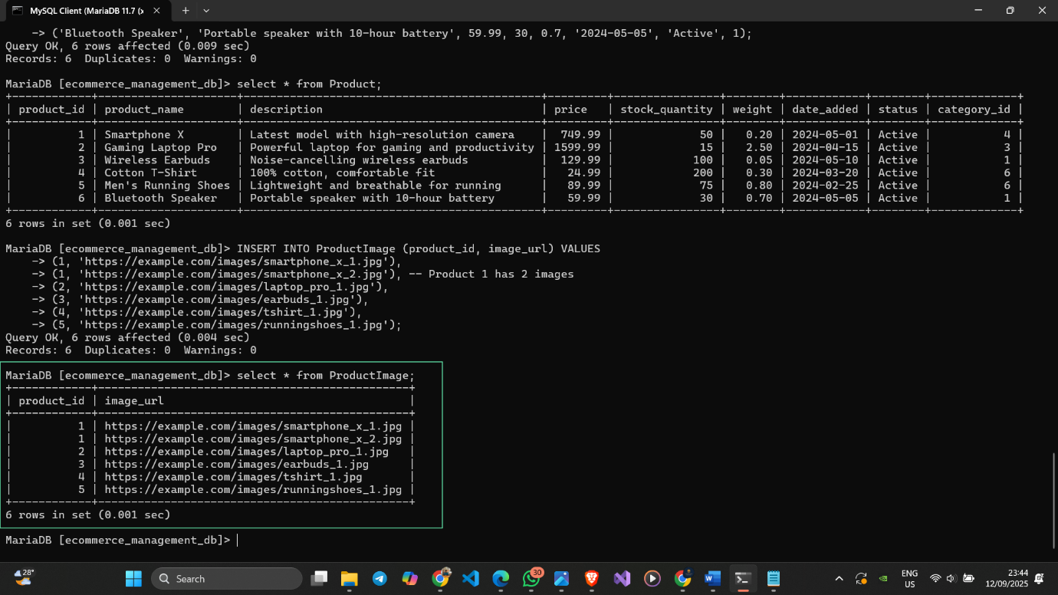

Figure 20 ProductImage Table with Inserted Data

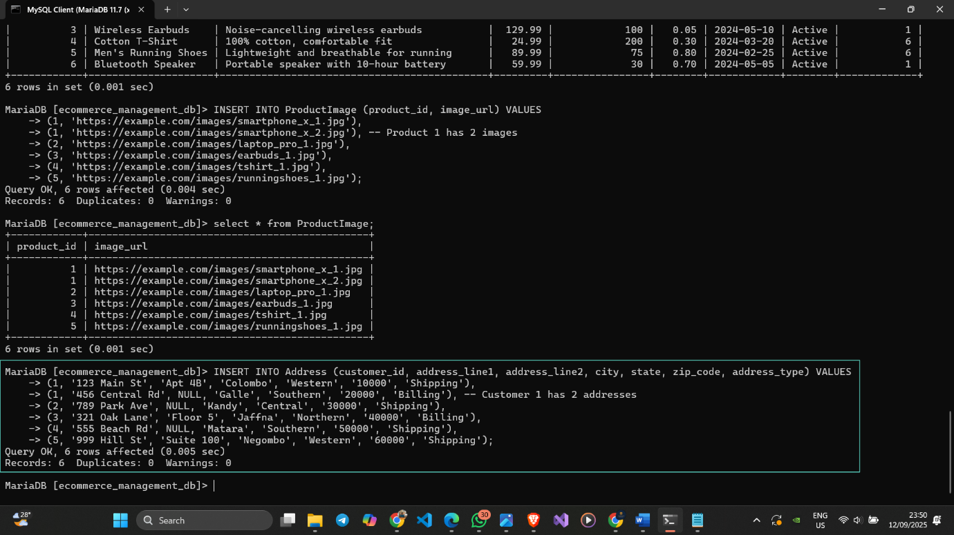

Figure 21 Inserting Data to the Address Table

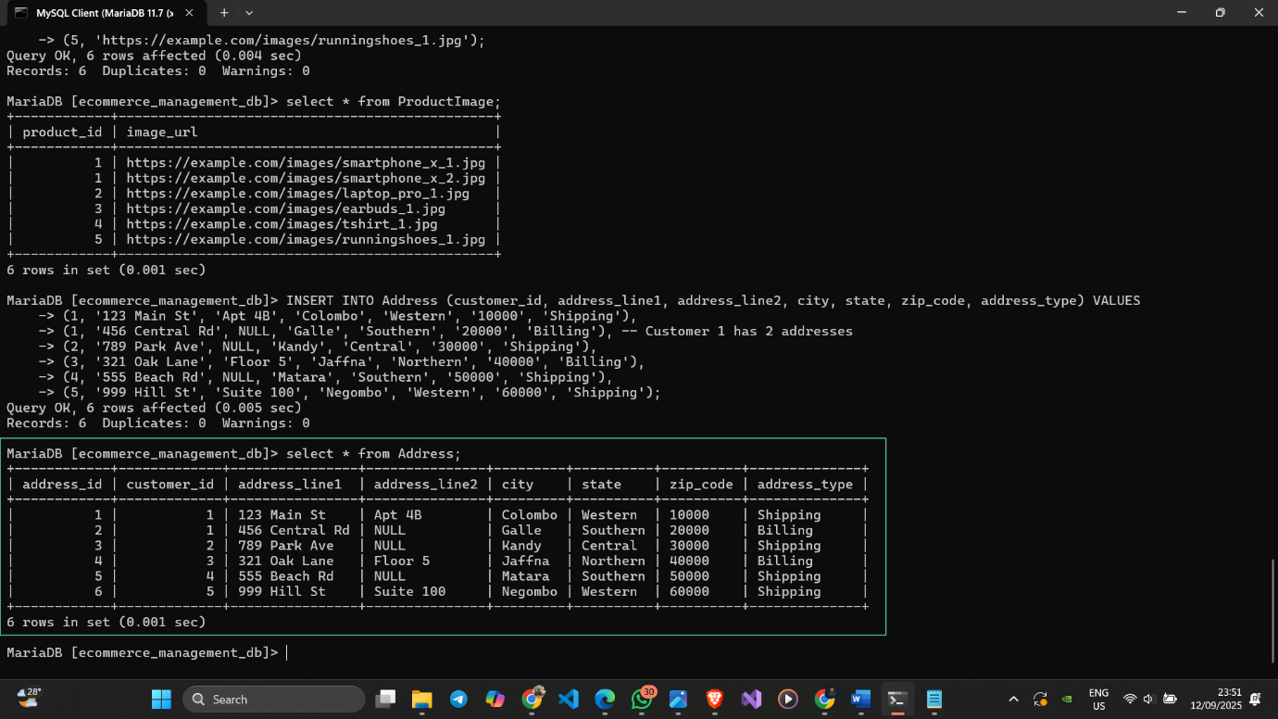

Figure 22 Address Table with Inserted Data

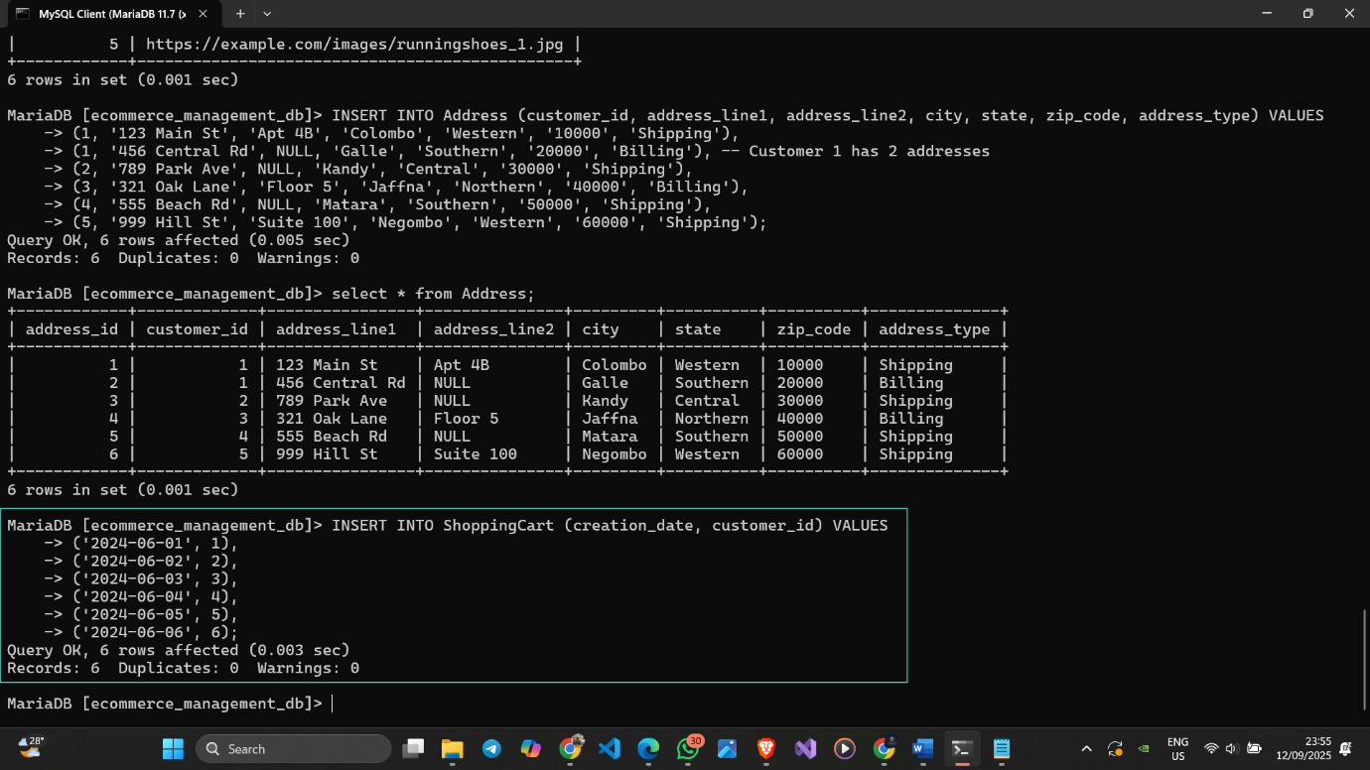

Figure 23 Inserting Data to the ShoppingCart Table

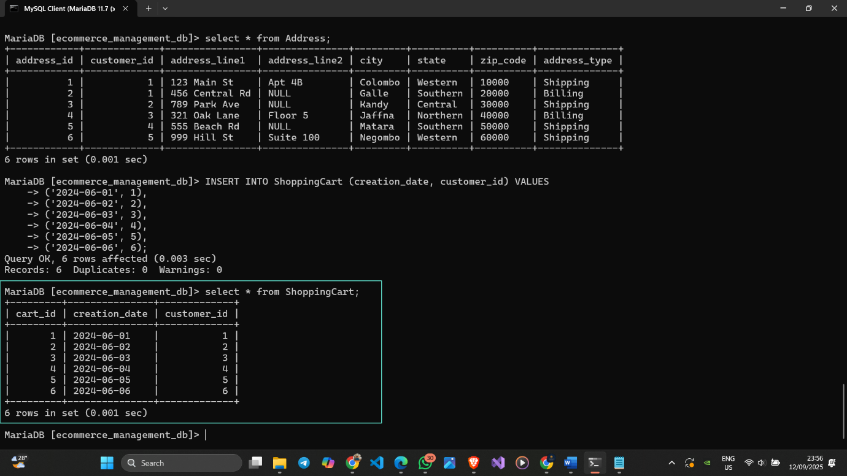

Figure 24 ShoppingCart Table with Inserted Data

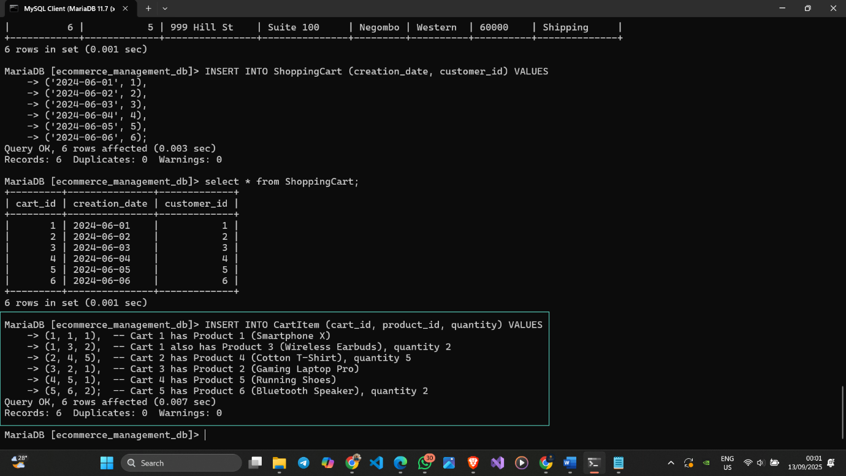

Figure 25 Inserting Data to the CartItem Table

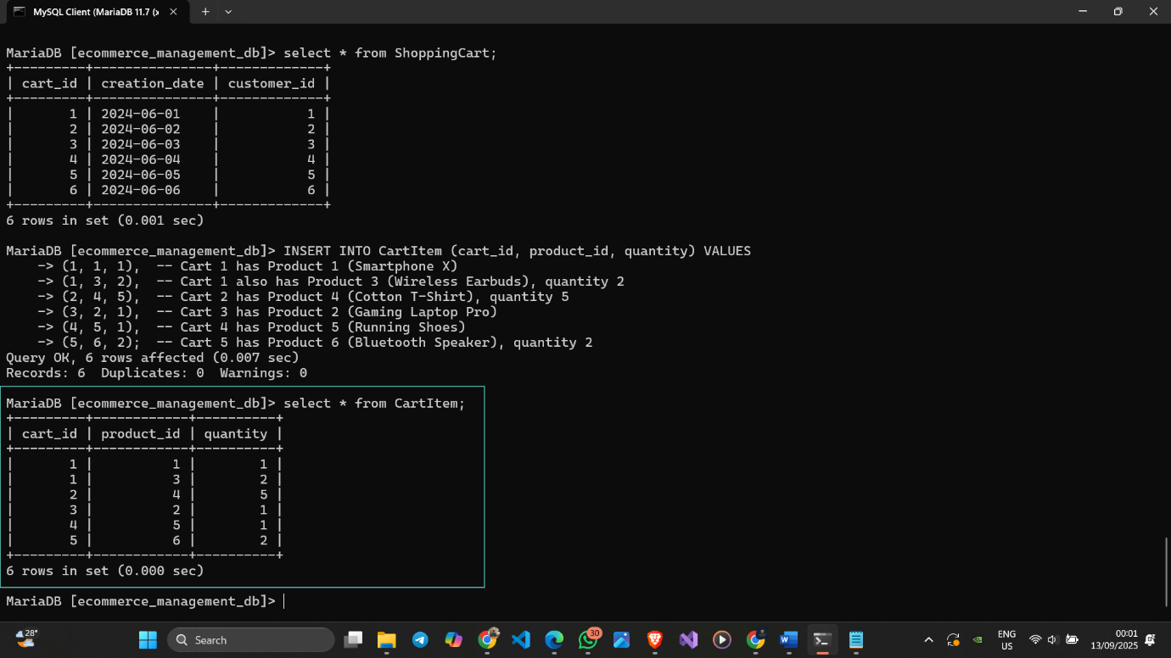

Figure 26 CartItem Table with Inserted Data

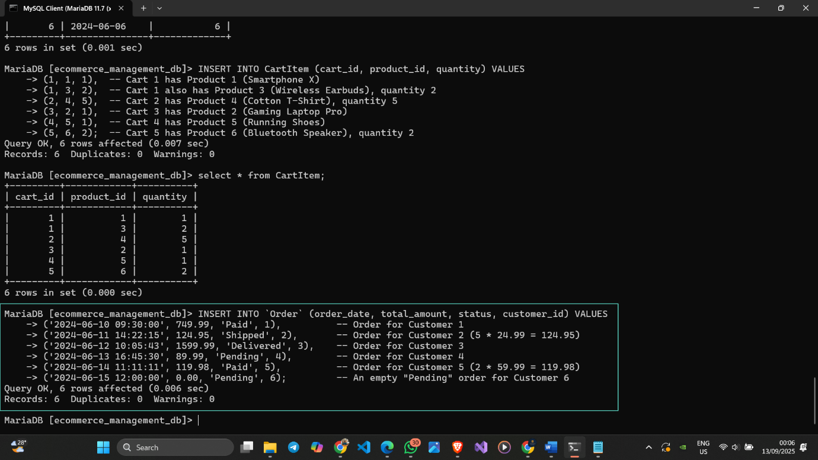

Figure 27 Inserting Data to the Order Table

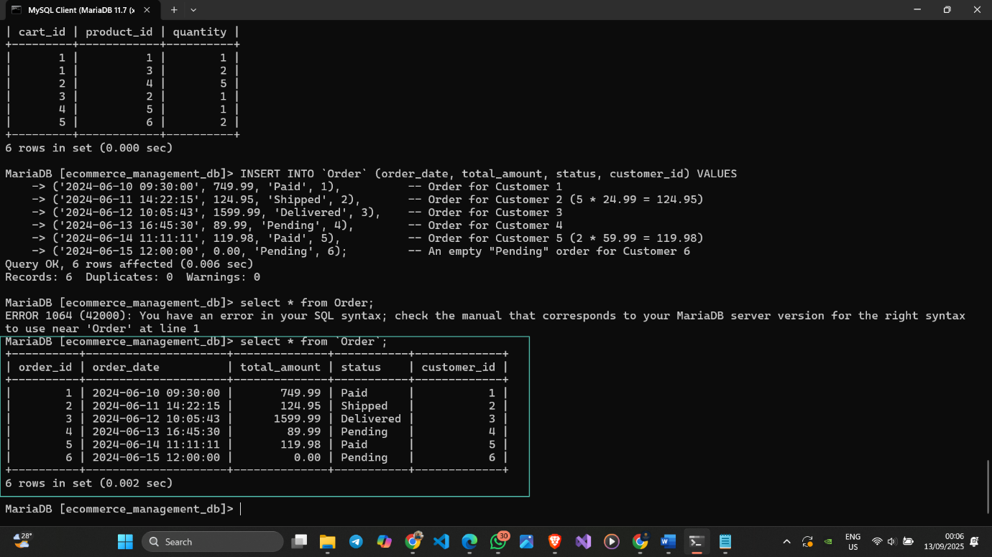

Figure 28 Order Table with Inserted Data

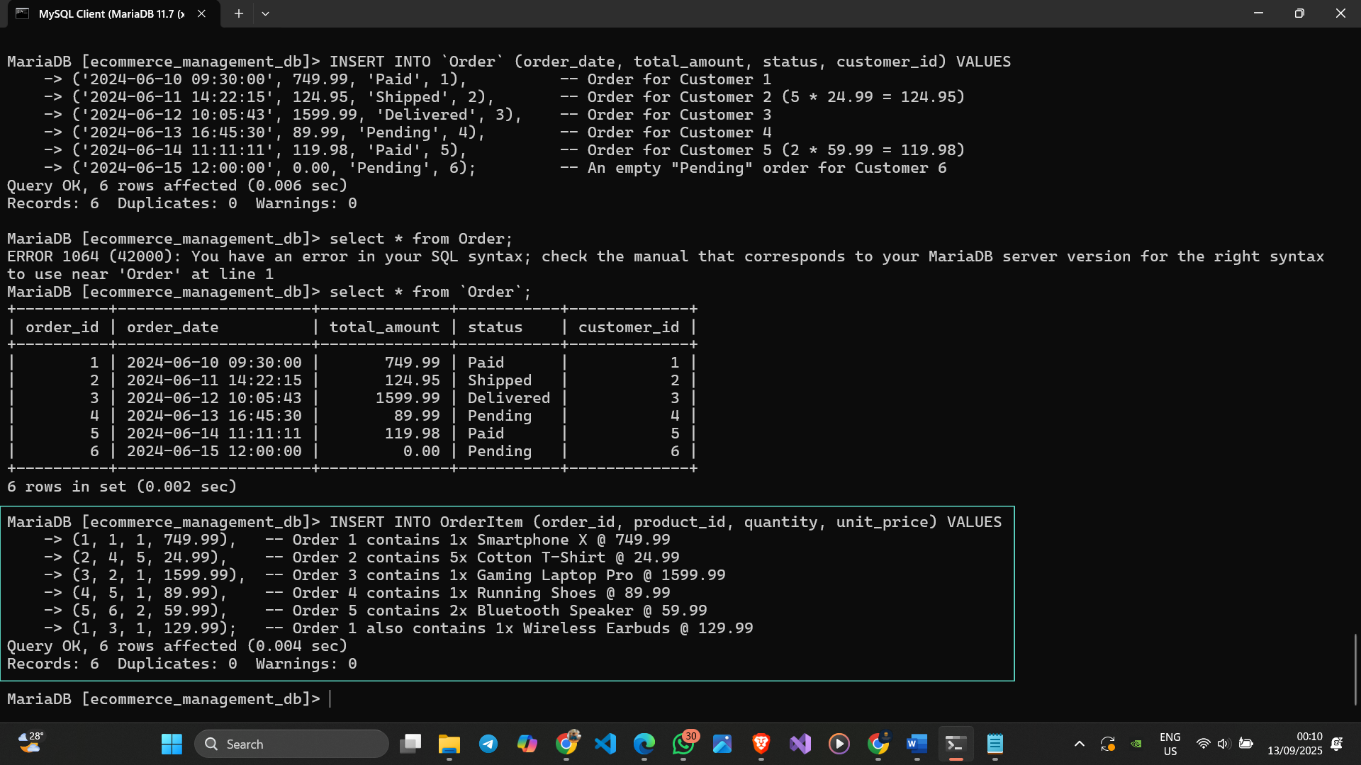

Figure 29 Inserting Data to the OrderItem Table

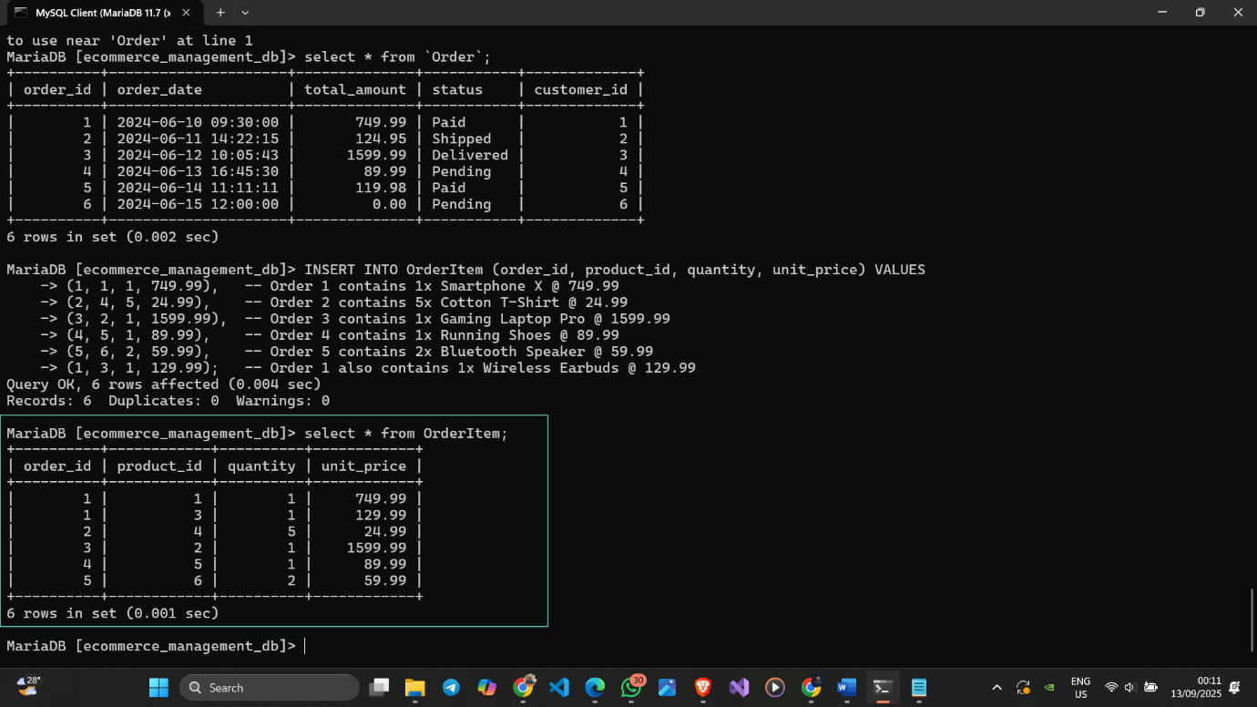

Figure 30 OrderItem Table with Inserted Data

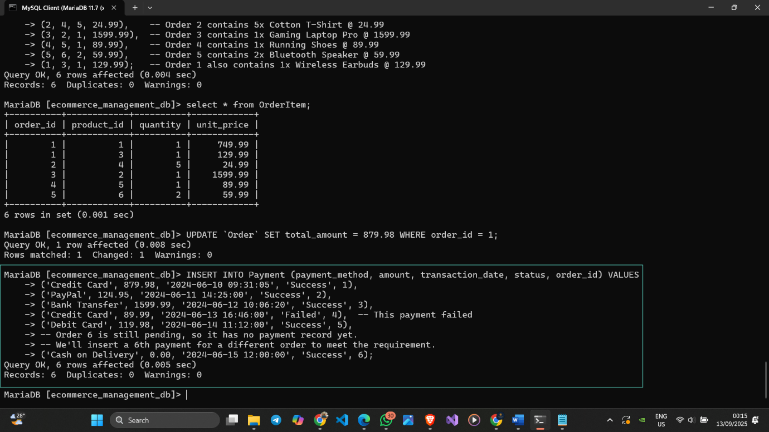

Figure 31 Inserting Data to the Payment Table

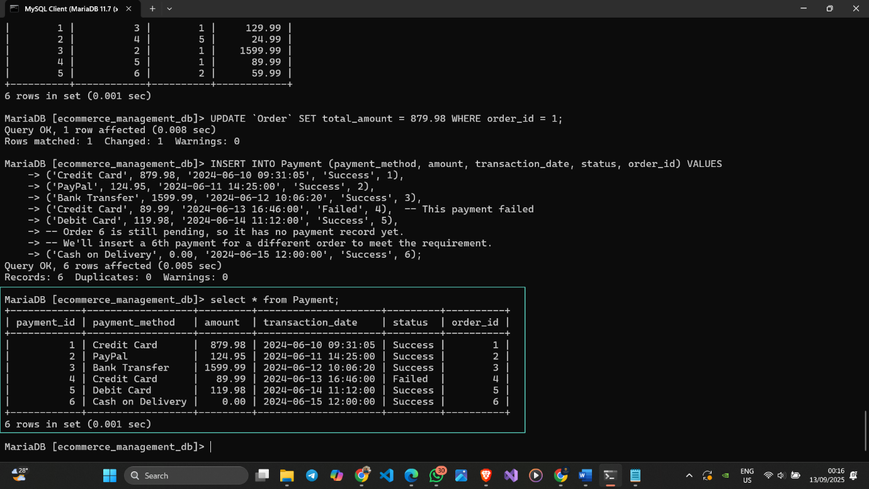

Figure 32 Payment Table with Inserted Data

## 4.4 Data Modification (UPDATE Operations)

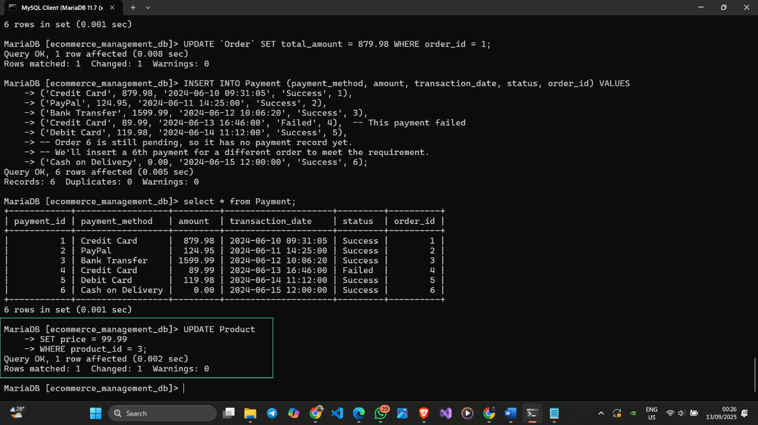

Figure 33 Update a Product's Price

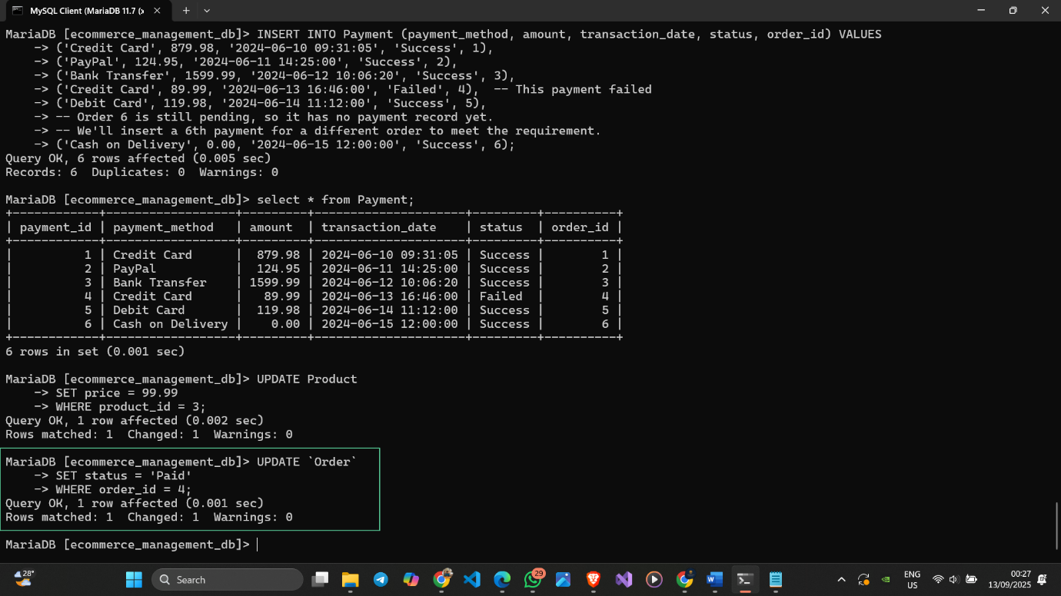

Figure 34 Update an Order's Status

## 4.5 Data Deletion (DELETE Operations)

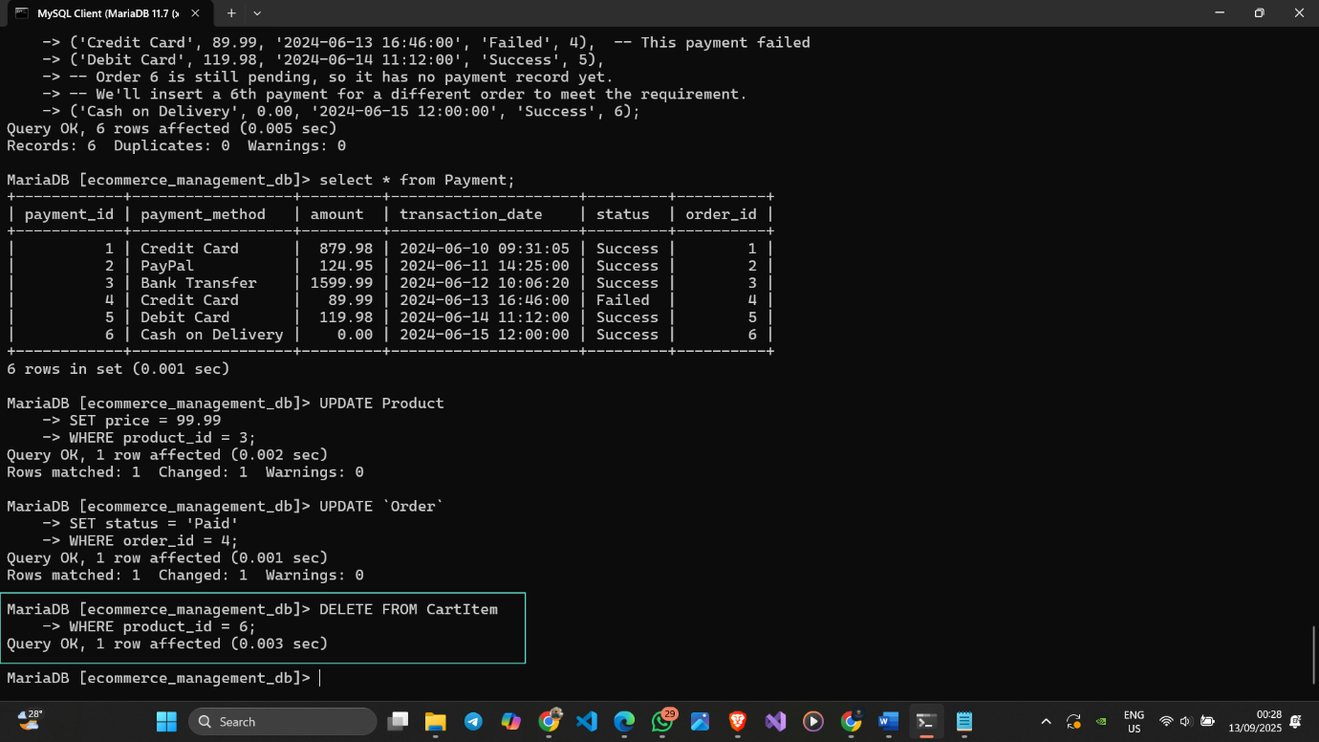

Figure 35 Delete from CartItem Table

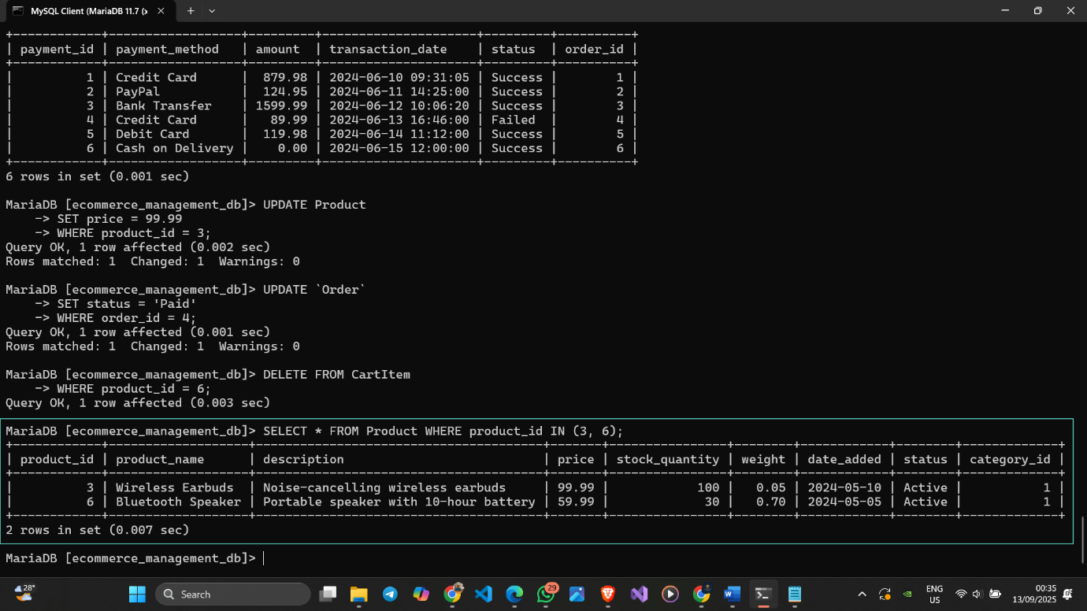

Figure 36 Verify the first Update operation

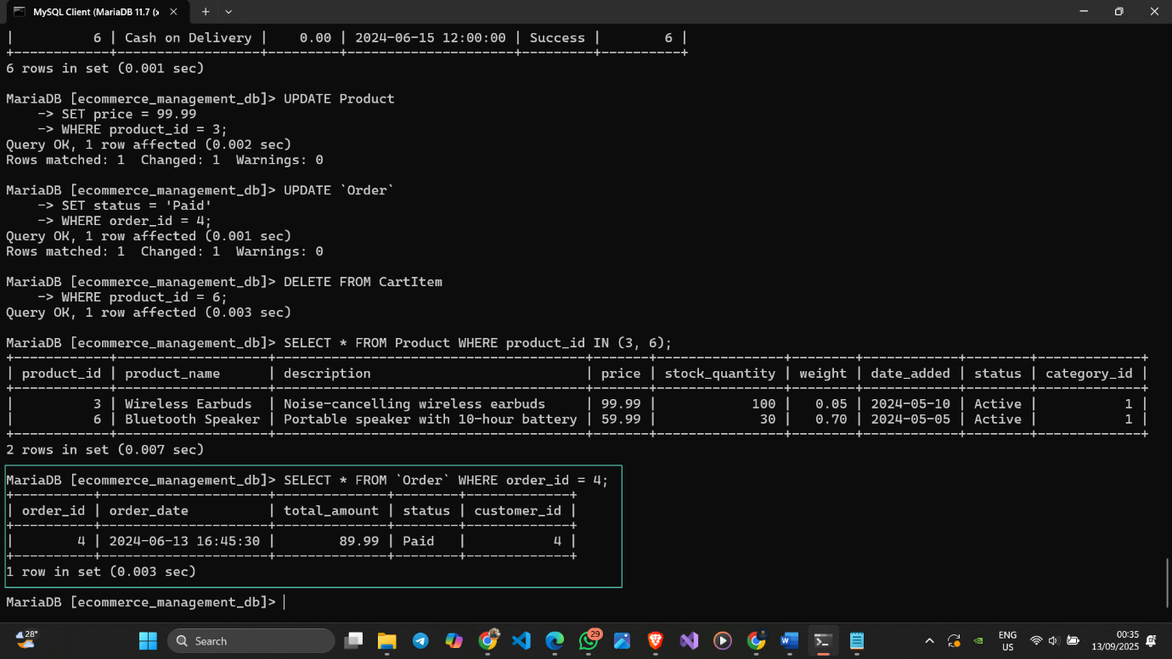

Figure 37 Verify the second Update operation

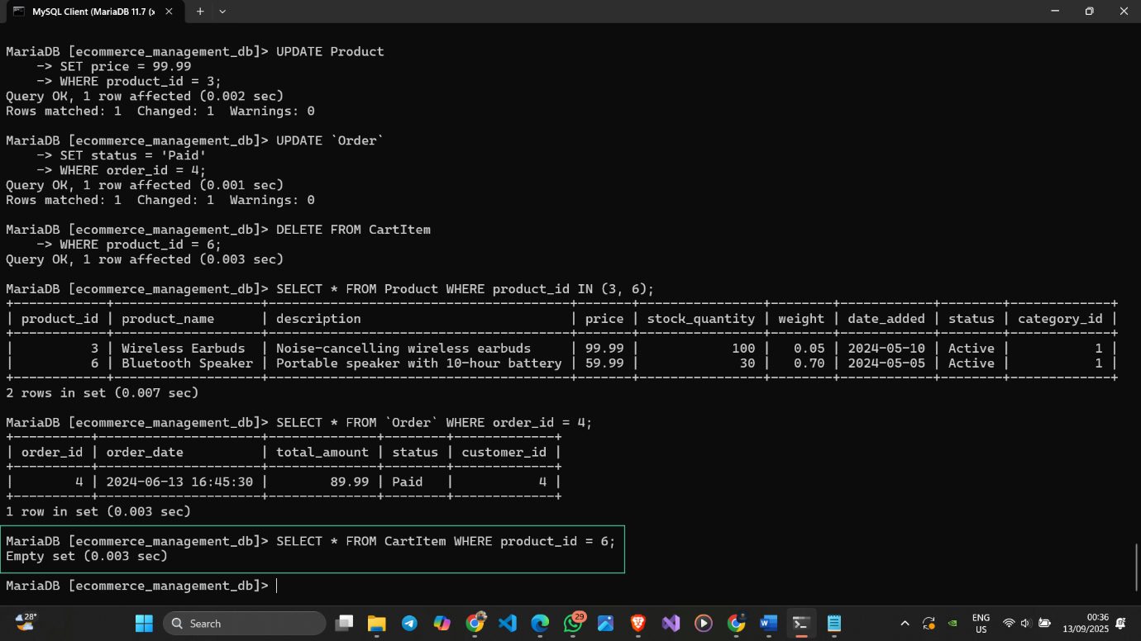

Figure 38 Verify the Delete operation

# CHAPTER 5 – TRANSACTIONS

## 5.1 Simple Queries

### 5.1.1 Select Operation

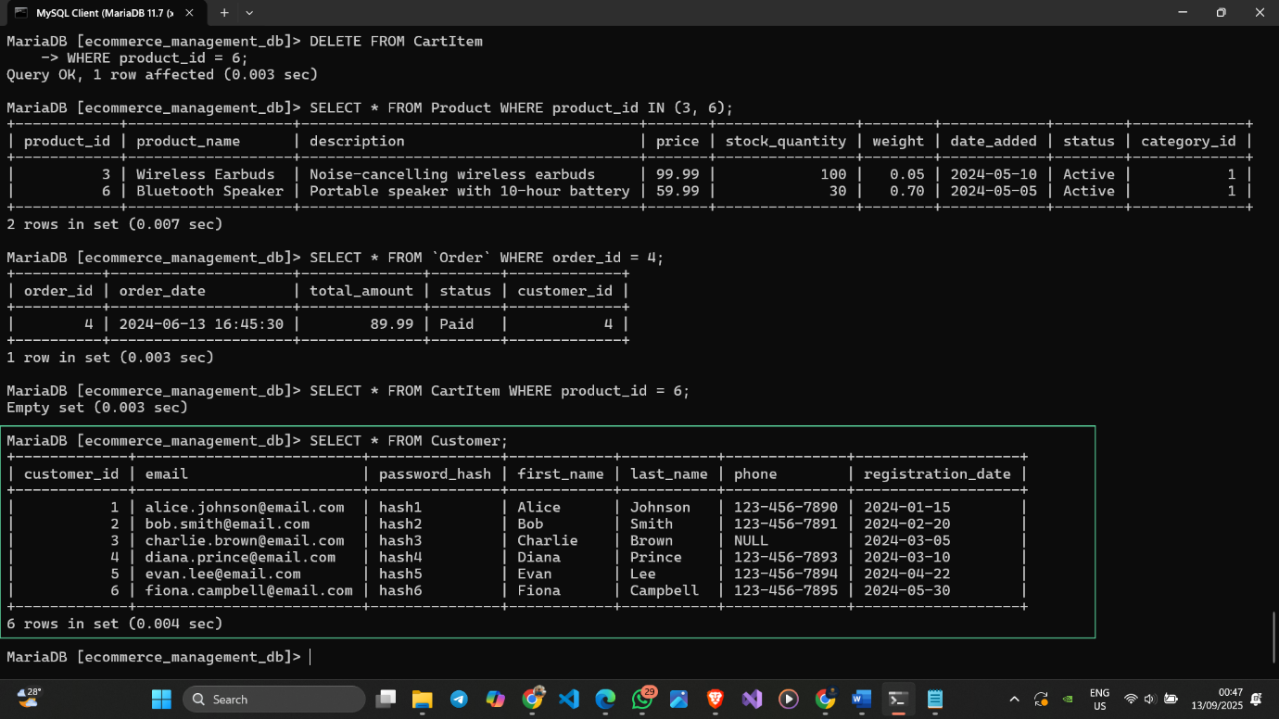

Figure 39 Select all columns from Customer Table

### 5.1.2 Project Operation

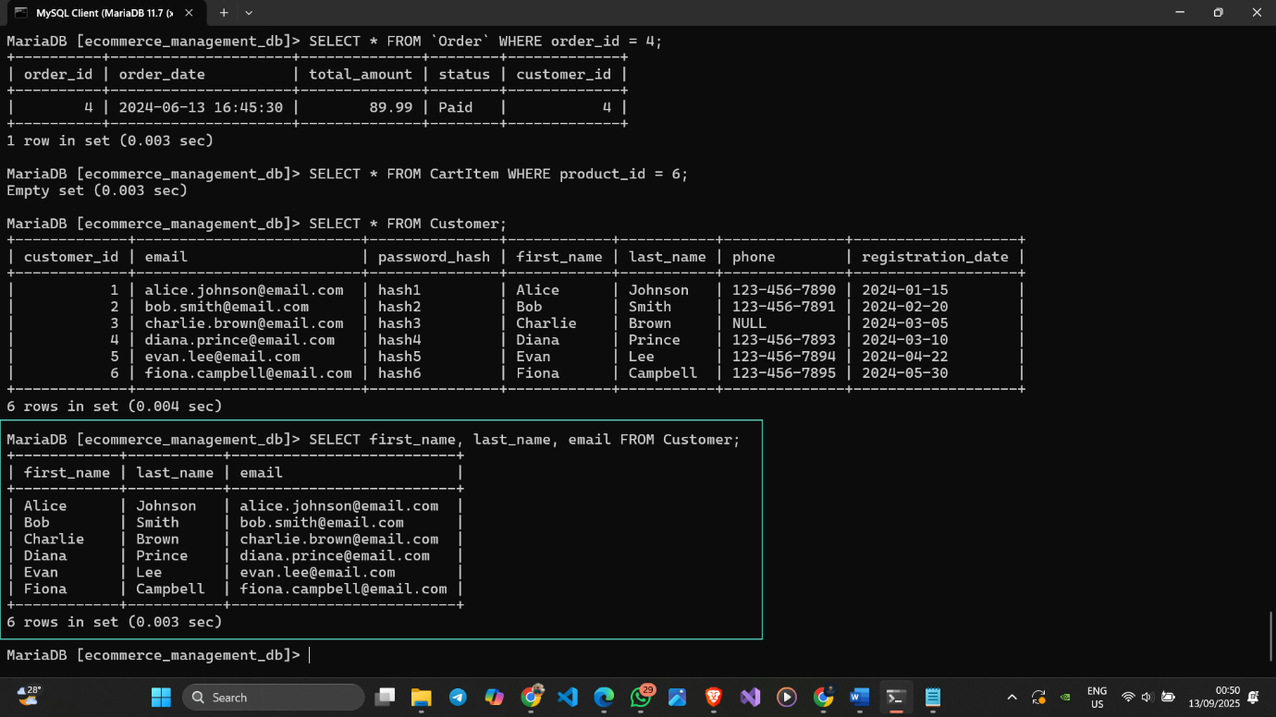

Figure 40 Select specific columns from Customer Table

### 5.1.3 Cartesian Product

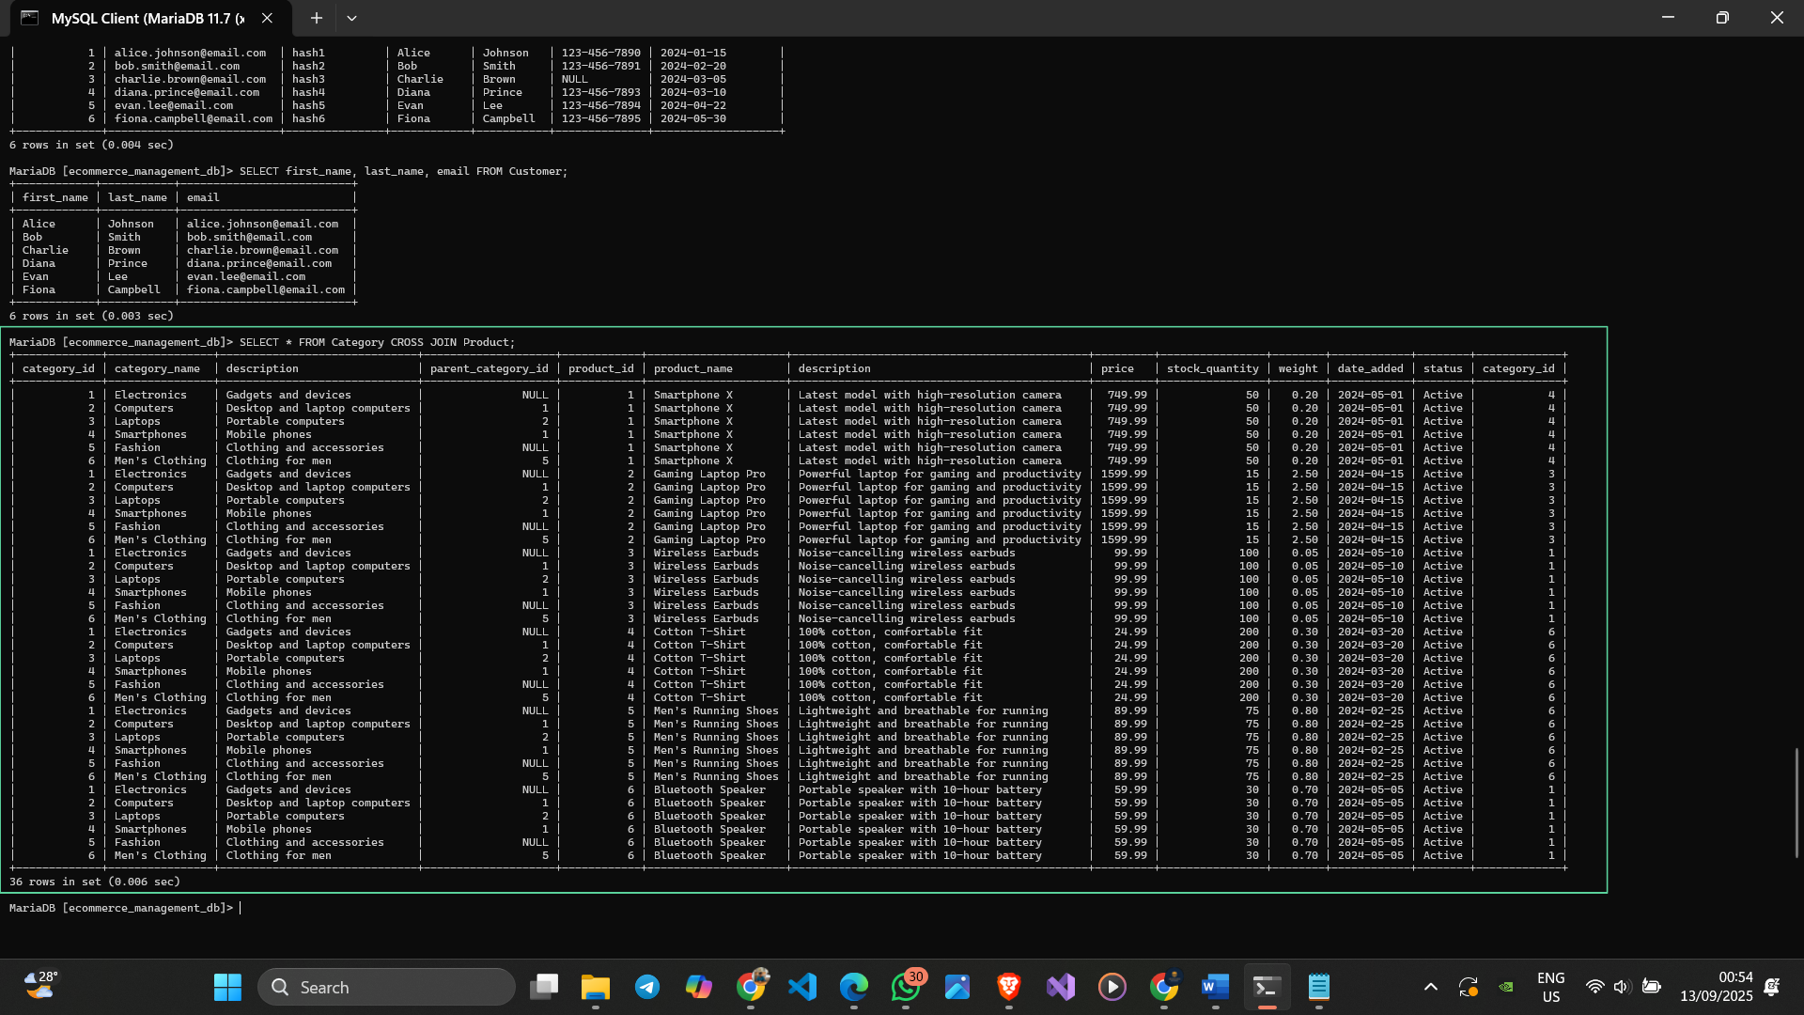

Figure 41Cartesian product between Category and Product Tables

### 5.1.4 Create View

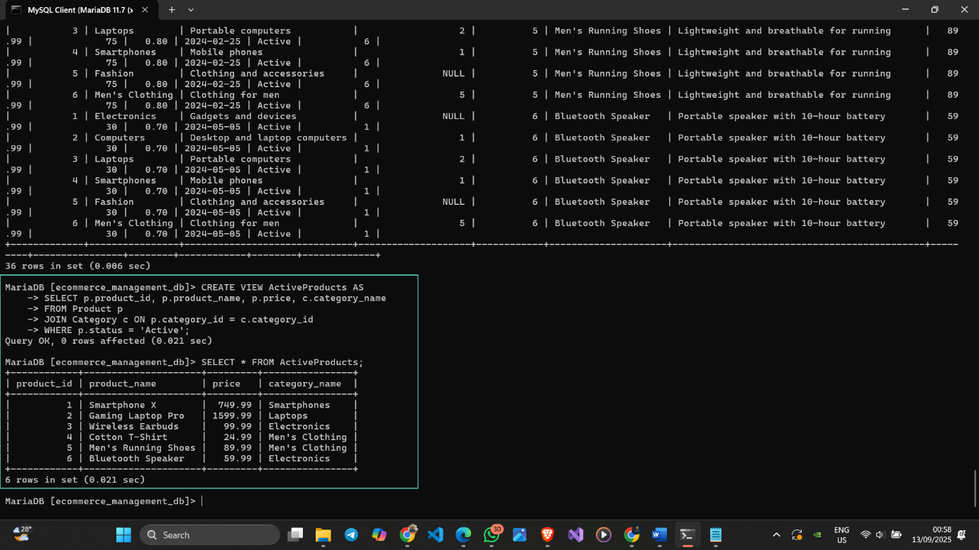

Figure 42 View for active products with their categories

### 5.1.5 Rename Operation

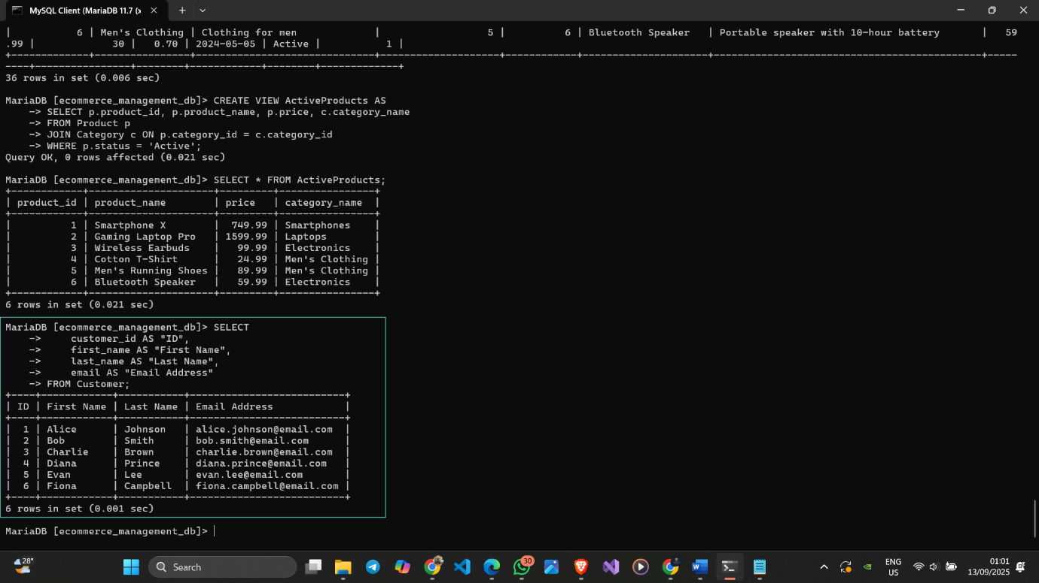

Figure 43 Rename Operation in Customer Table

### 5.1.6 Aggregate Function

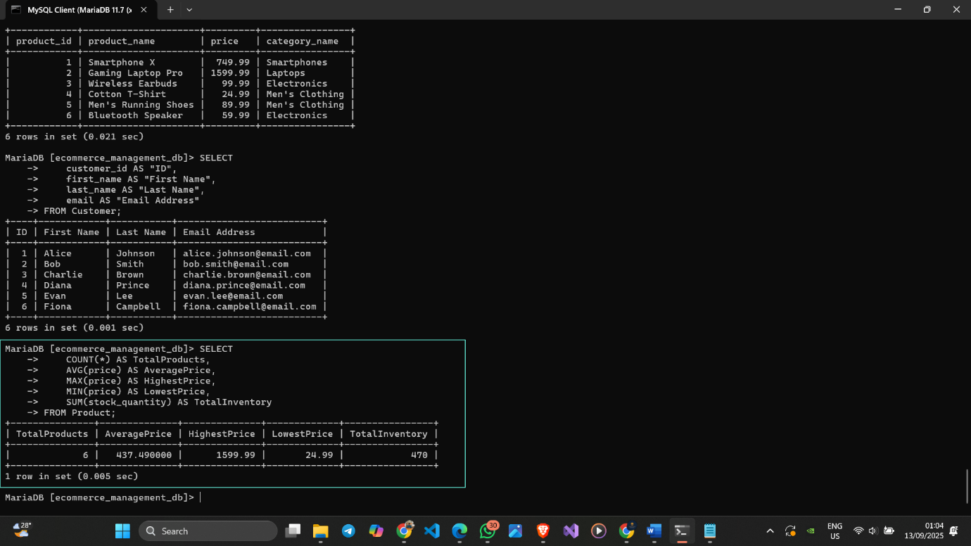

Figure 44 Aggregate Functions in Product Table

### 5.1.7 LIKE Keyword

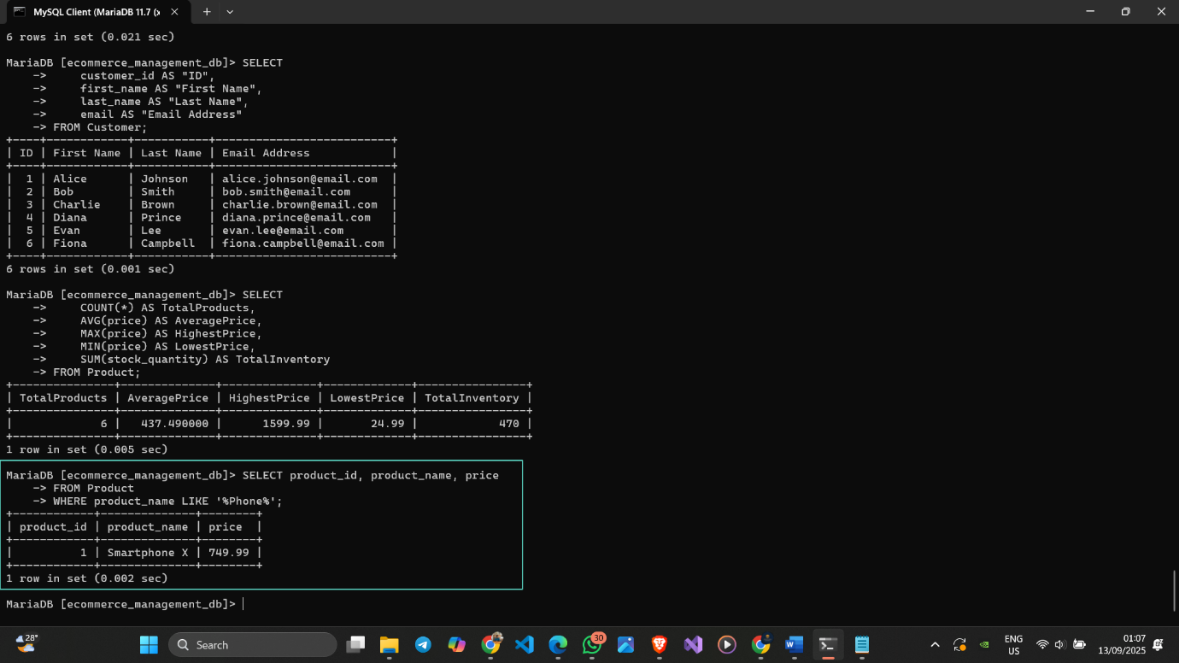

Figure 45 Use of LIKE in Product Table

## 5.2 Complex Queries

### 5.2.1 Set Operations (Union, Intersection, Set Difference, Division)

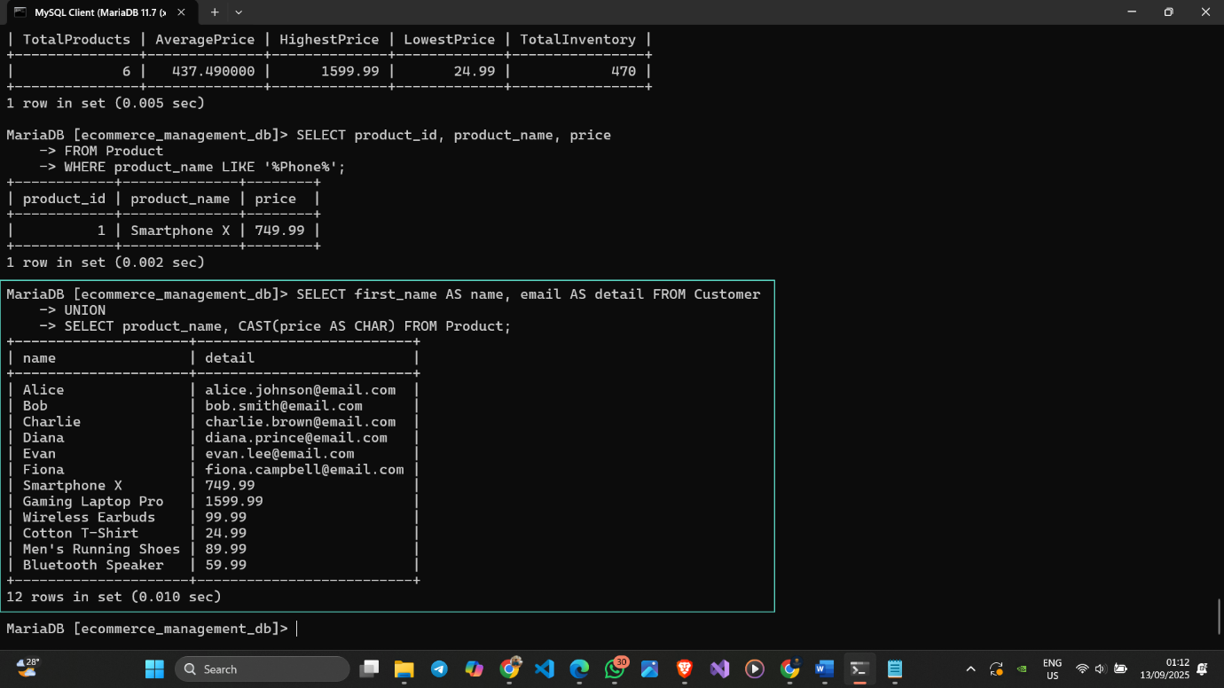

Figure 46 Union Operation

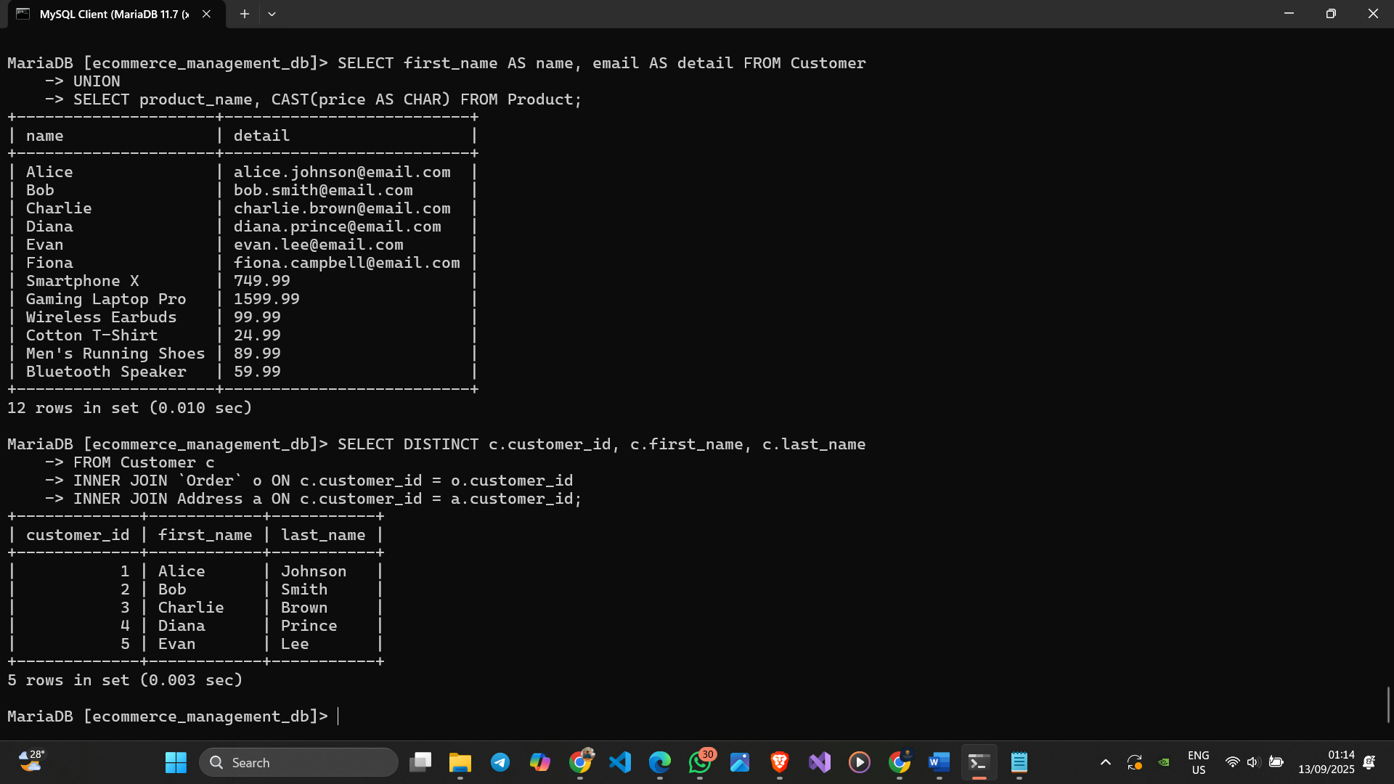

Figure 47 Intersection Operation

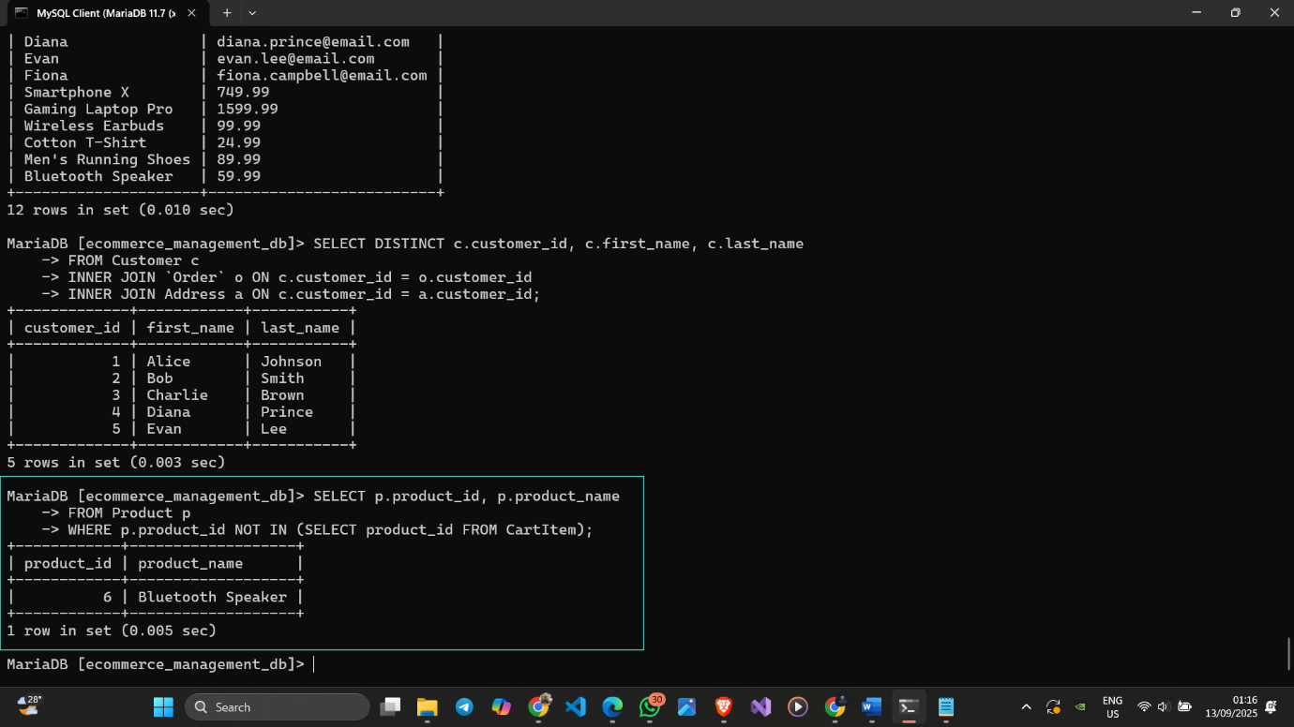

Figure 48 Set Difference Operation

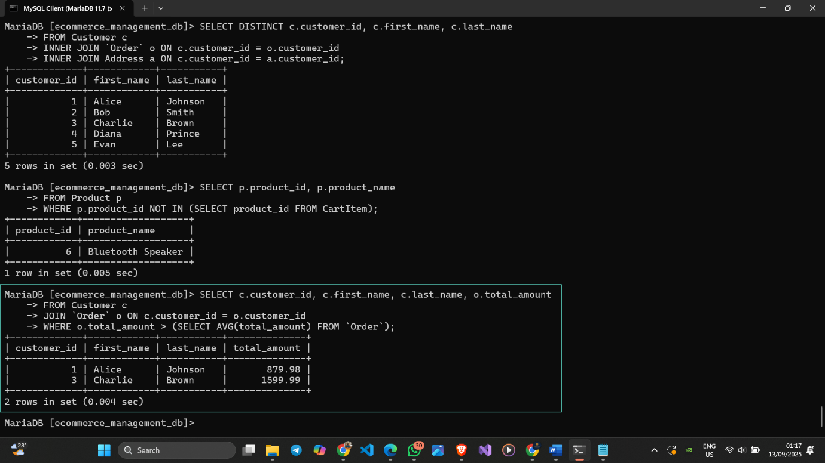

Figure 49 Division Operation

### 5.2.2 Join Operations (Inner, Natural, Left Outer, Right Outer, Full Outer)

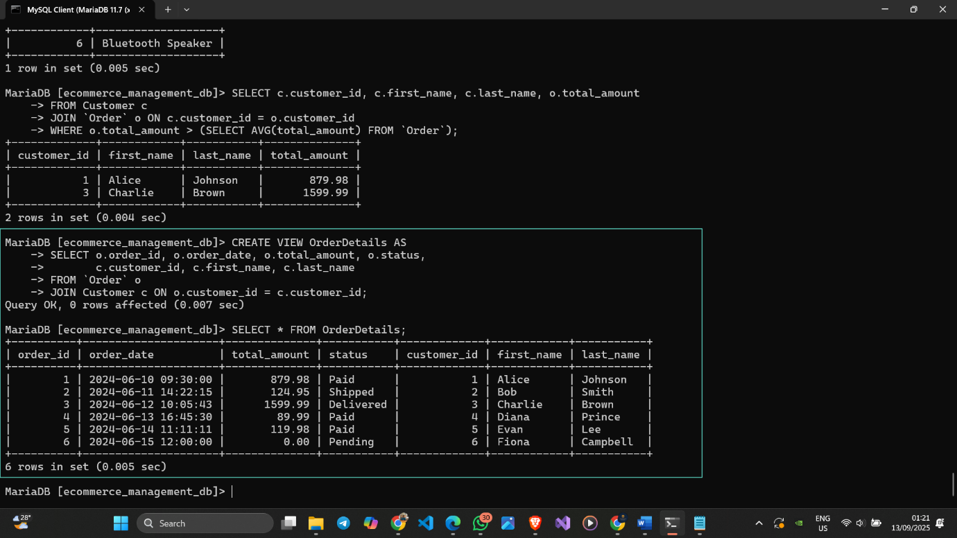

Figure 50 Inner Join Operation

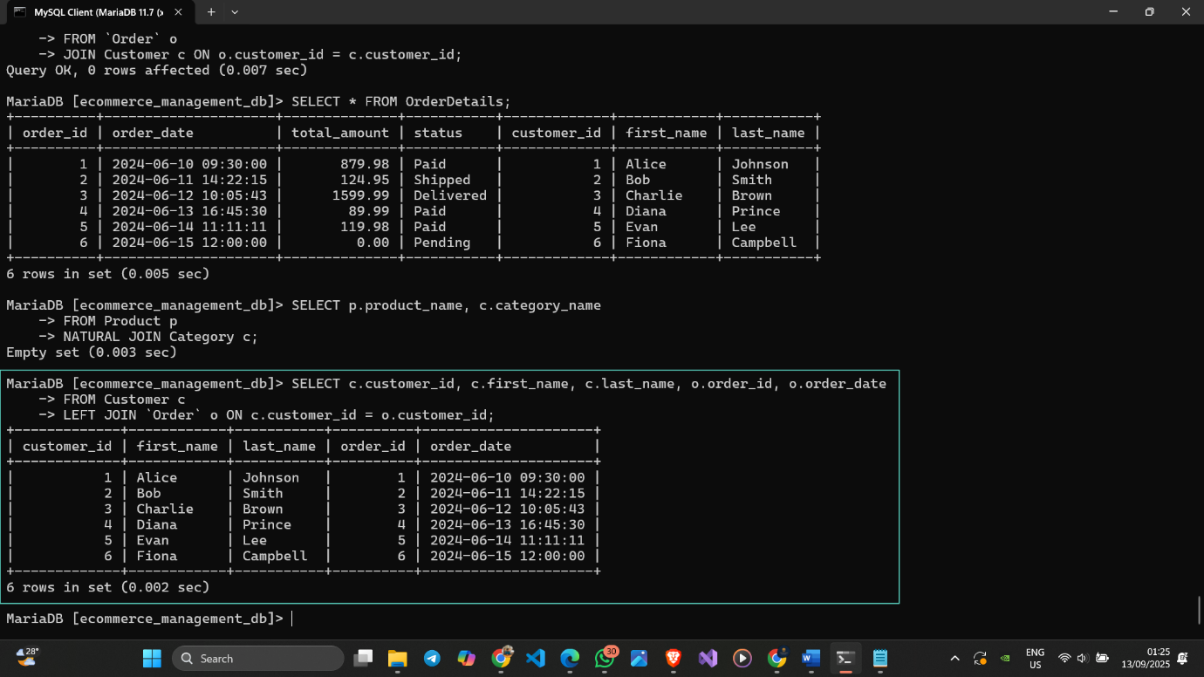

Figure 51 Left Outer Join Operation

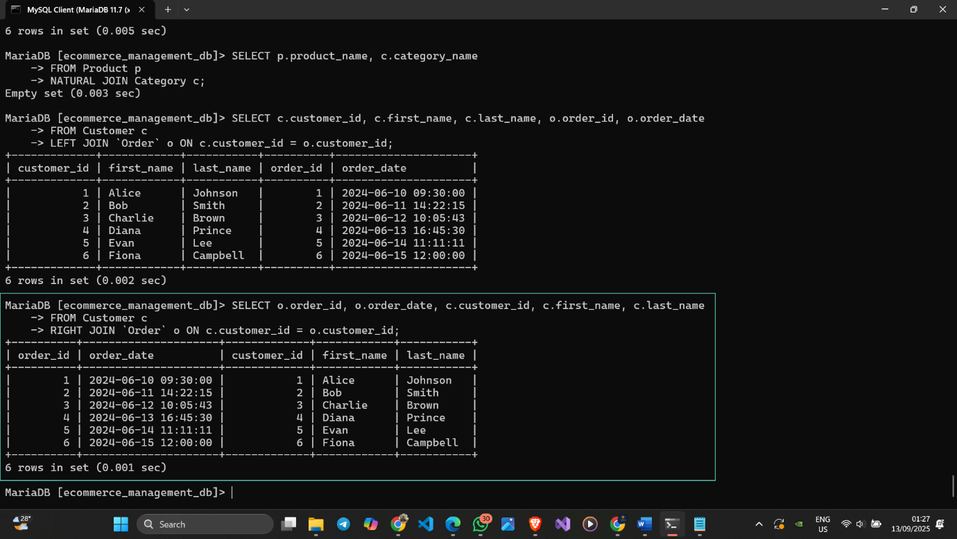

Figure 52 Right Outer Join Operation

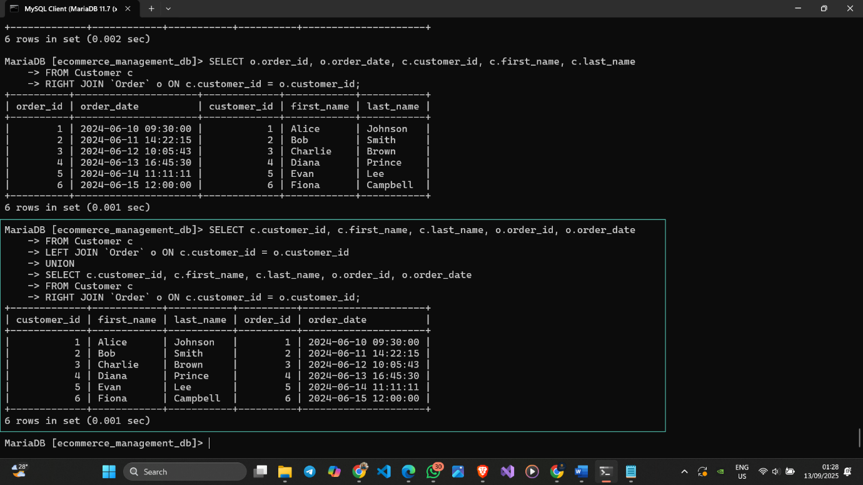

Figure 53 Full Outer Join Operation

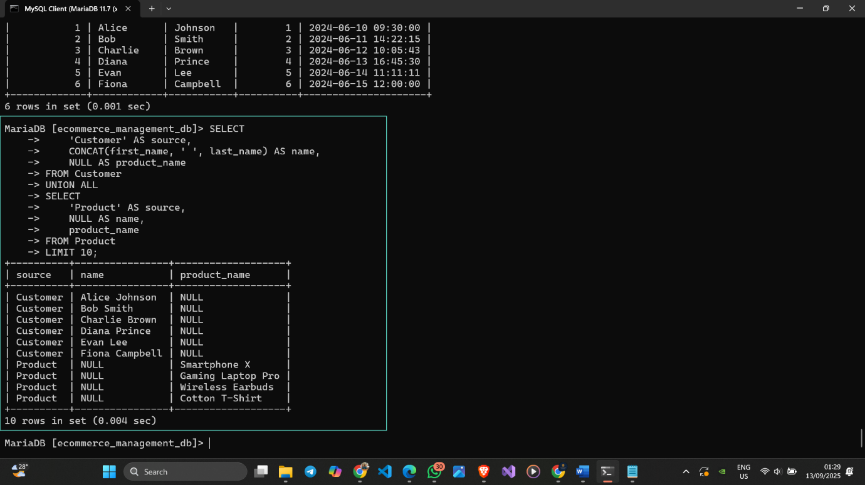

Figure 54 Outer Union Operation

### 5.2.3 Nested Queries

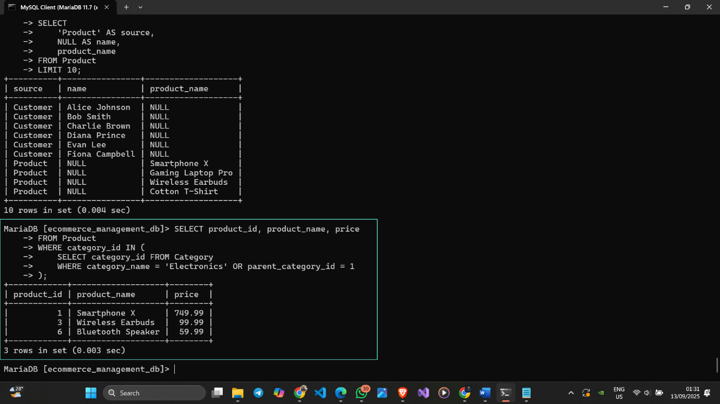

Figure 55 Nested Query with IN

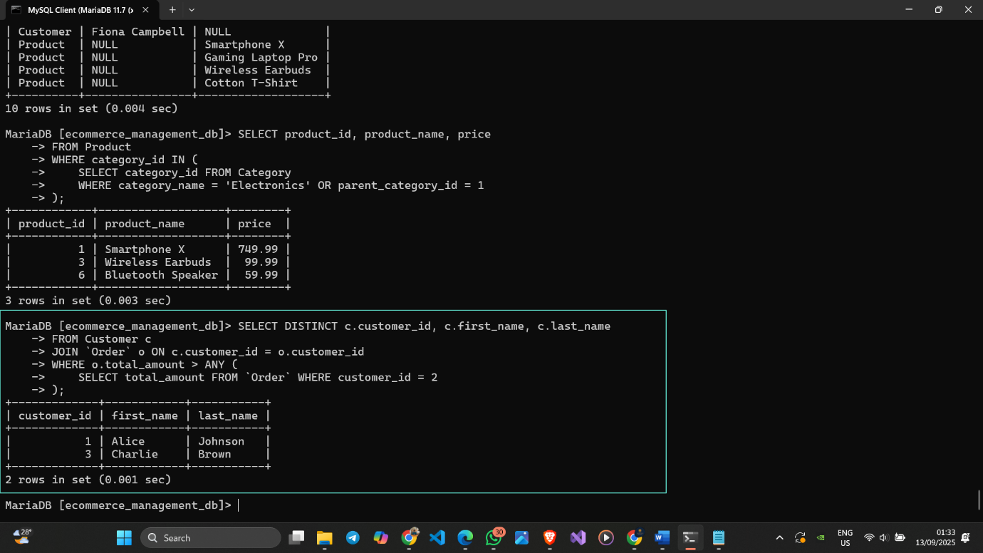

Figure 56 Nested Query with ANY

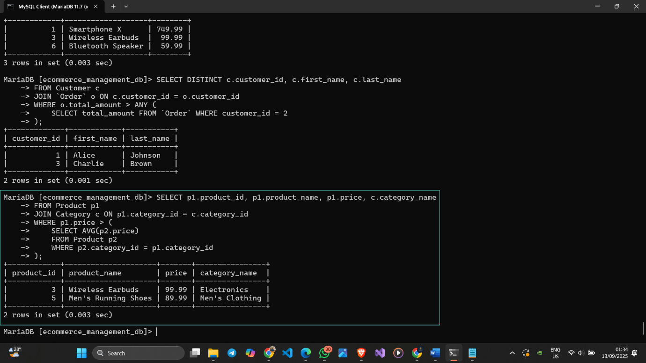

Figure 57 Correlated Nested Query

# CHAPTER 6 - DATABASE TUNING

## 6.1 Query Tuning Methodology

We will select 10 complex queries from Chapter 5 and attempt to tune them. The primary method will be adding **indexes** on columns used in WHERE, JOIN, and ORDER BY clauses. We will use the EXPLAIN command to analyze the query execution plan before and after tuning to prove the improvement. We will compare the number of rows scanned ("rows" in the EXPLAIN output).

## 6.2 Analysis of Original Queries

First, we need to see how MariaDB currently executes the queries. We do this by putting EXPLAIN before the query.

## 6.3 Tuned Queries and Index Implementation

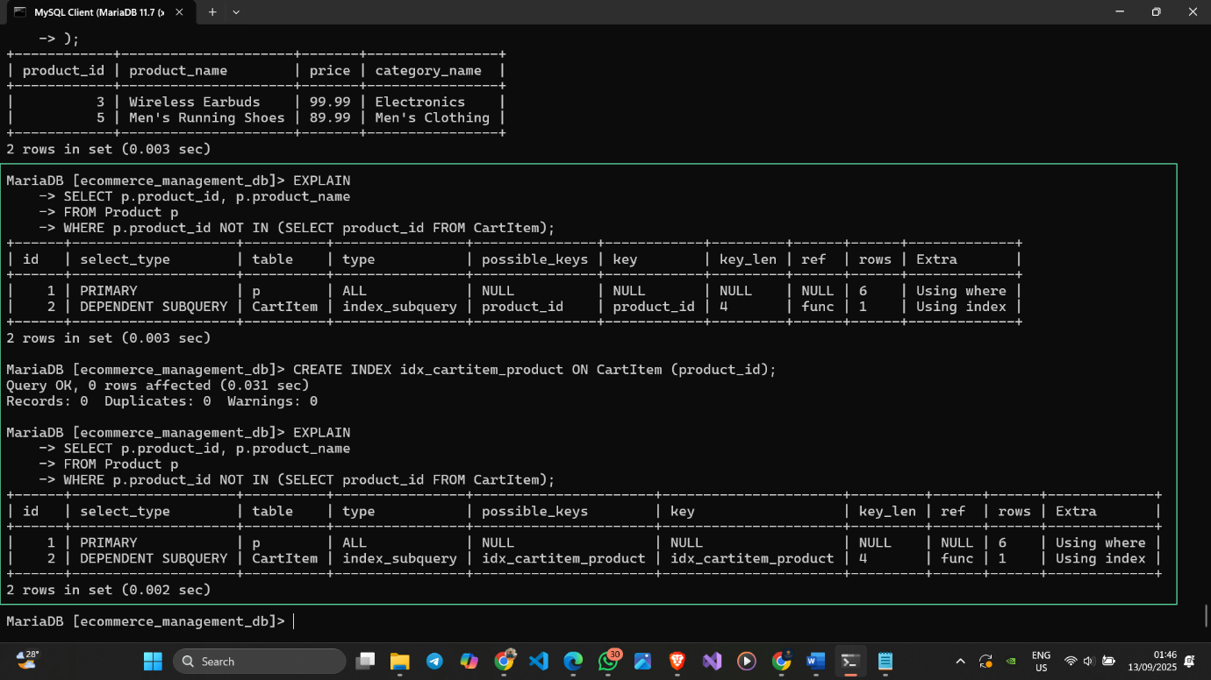

Figure 58 Before tunned and after tuned for query 1

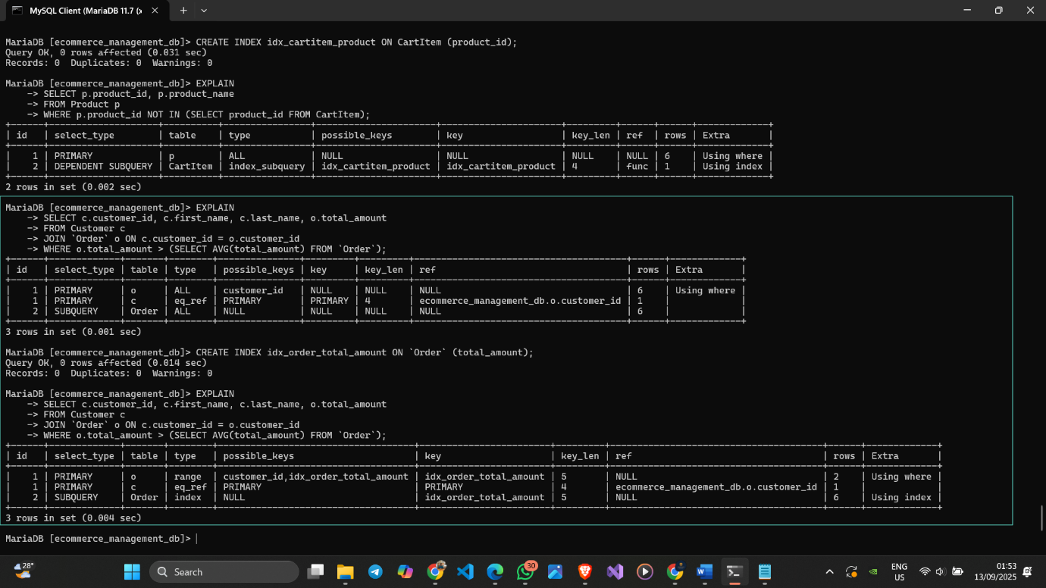

Figure 59 Before tunned and after tuned for query 2

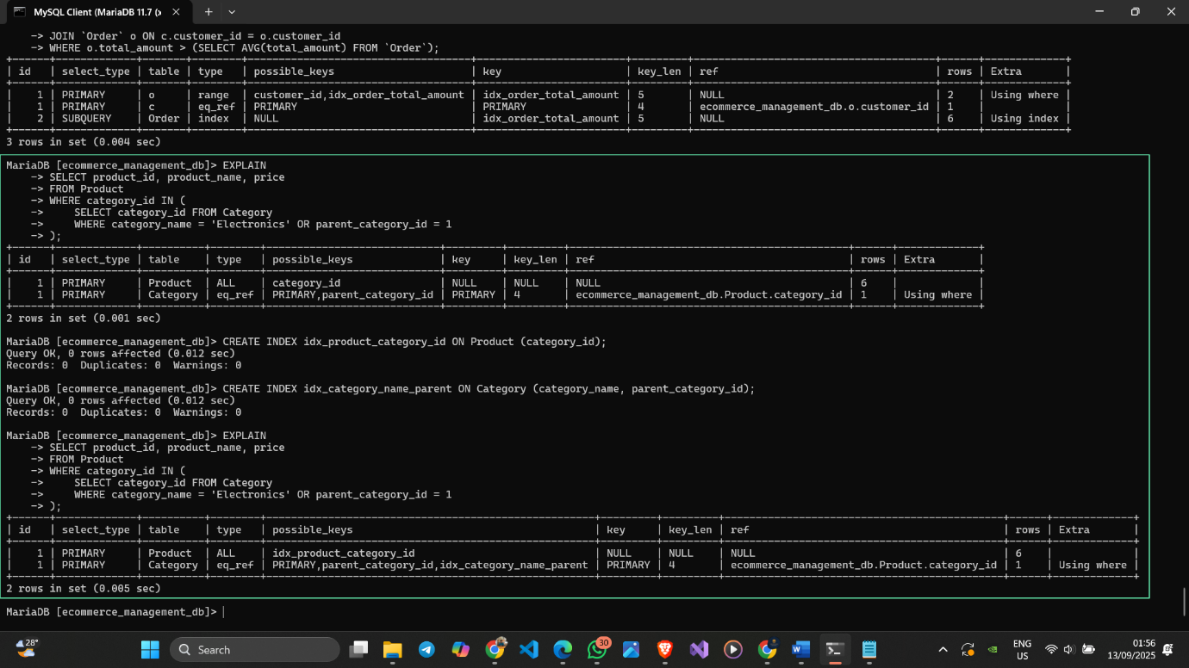

Figure 60 Before tunned and after tuned for query 3

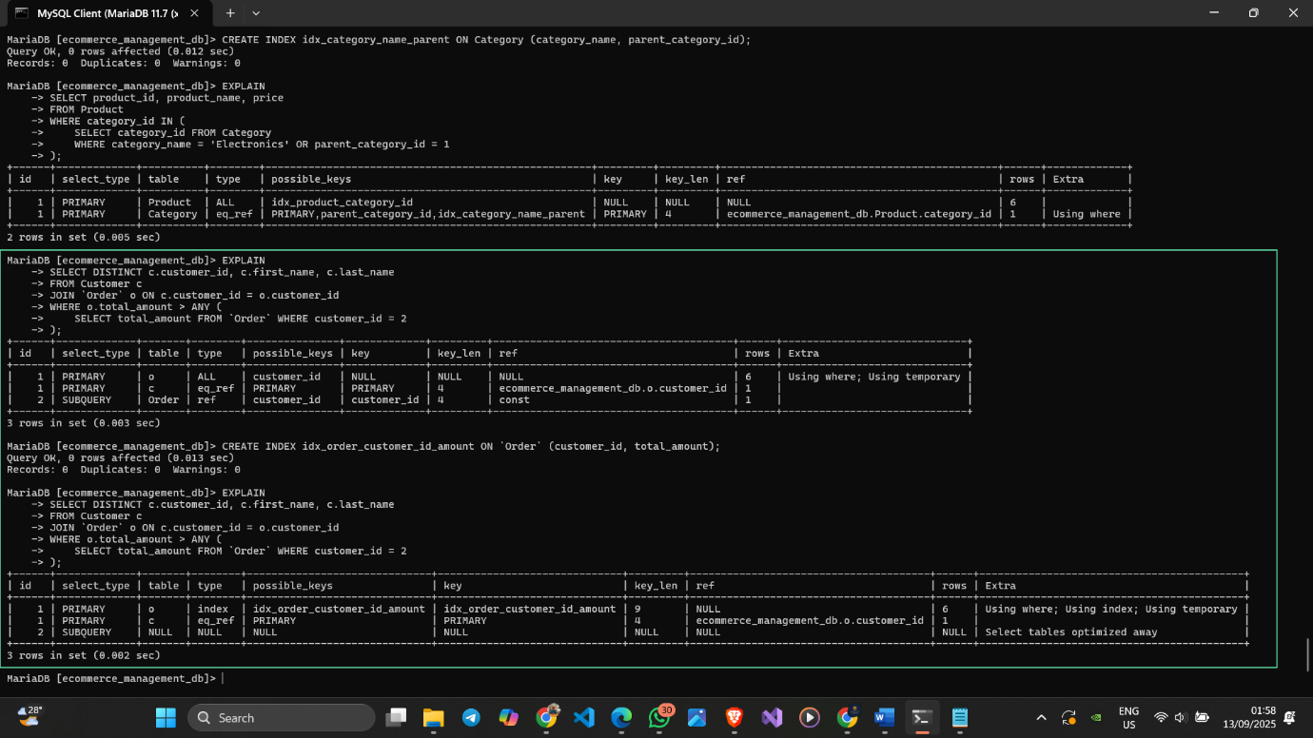

Figure 61 Before tunned and after tuned for query 4

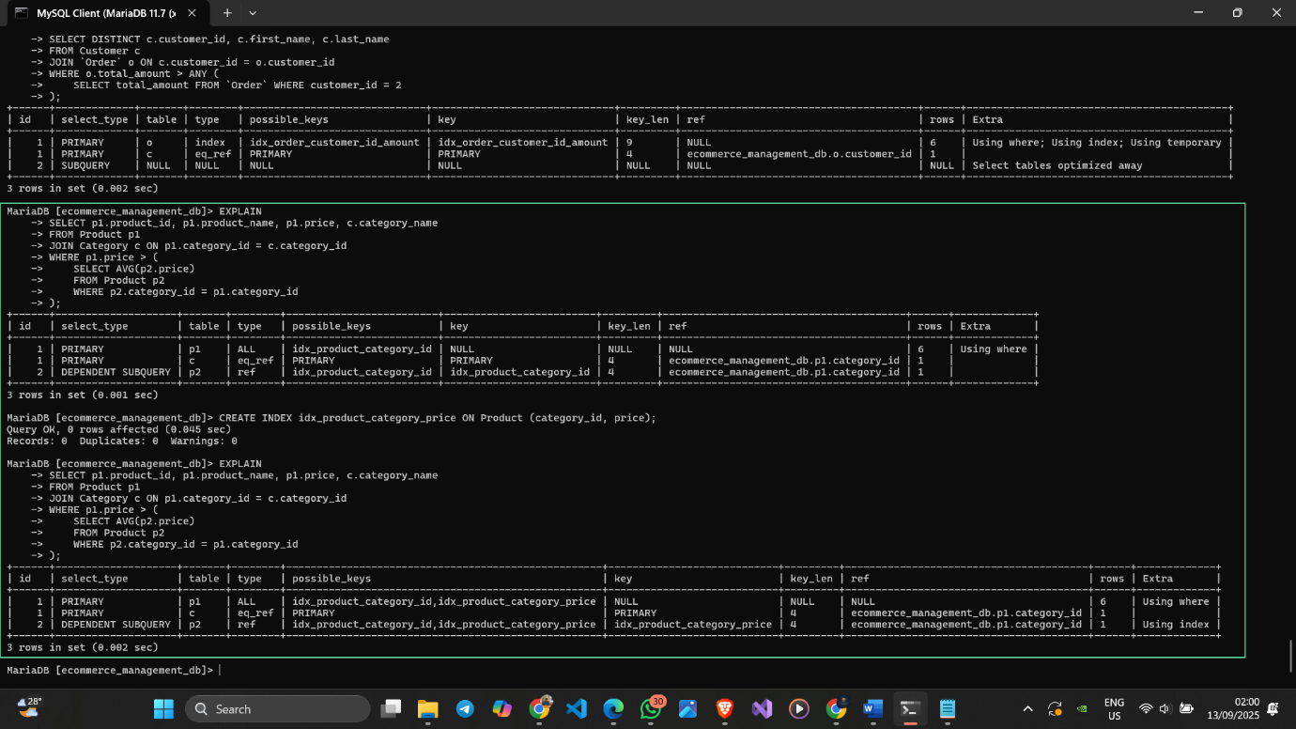

Figure 62 Before tunned and after tuned for query 5

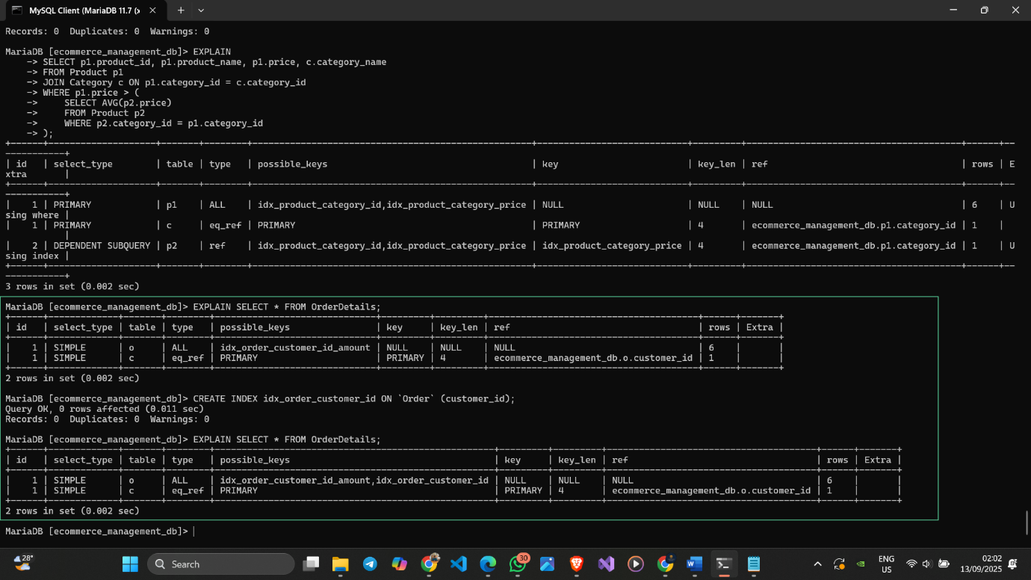

Figure 63 Before tunned and after tuned for query 6

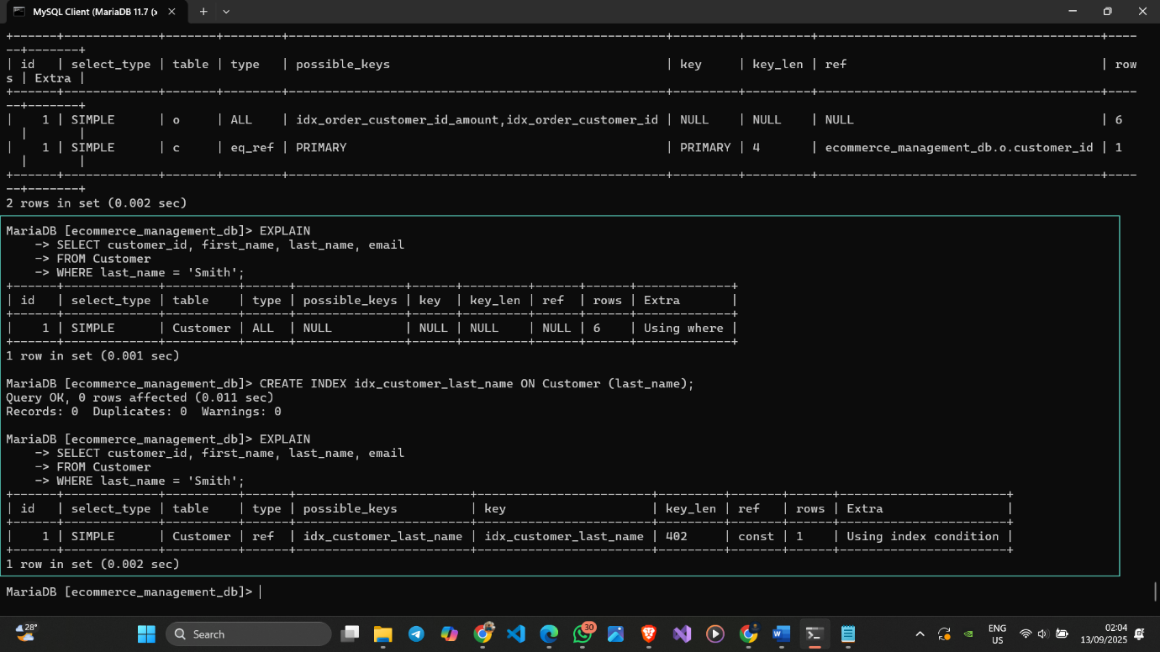

Figure 64 Before tunned and after tuned for query 7

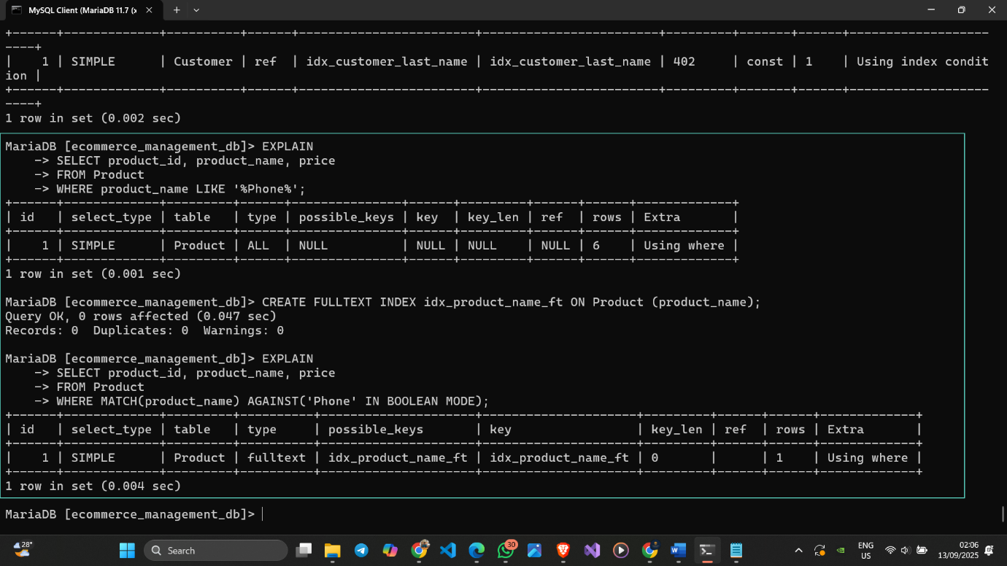

Figure 65 Before tunned and after tuned for query 8

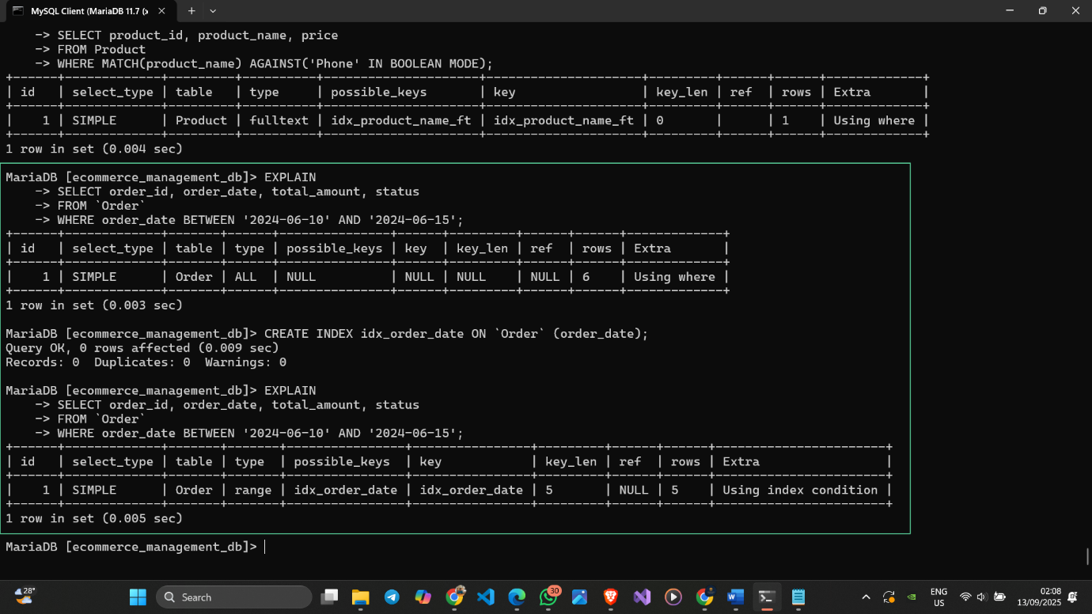

Figure 66 Before tunned and after tuned for query 9

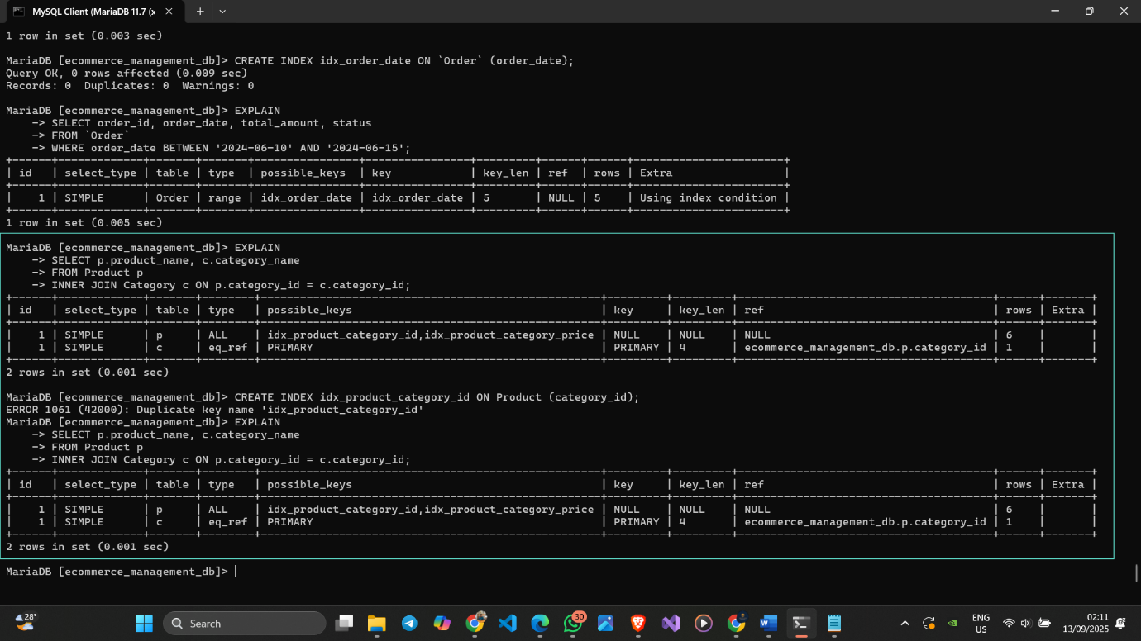

Figure 67 Before tunned and after tuned for query 10

## 6.4 Performance Comparison

Example: This query finds products never added to a cart. Initially, MariaDB had to perform a full table scan on the CartItem table, examining all 6 rows. After creating an index on CartItem(product_id), the database could use this index to quickly locate the required values, reducing the number of examined rows to 1. This significantly improves the query's performance.

Like this etc…